The status of U.S marine mammal stocks and stock assessments
Christopher M. Free^{1,2}*, Yutian Fang², Eva Juengling Bean²

¹ Marine Science Institute, University of California, Santa Barbara, Santa Barbara, CA, 93106, USA
² Bren School of Environmental Science and Management, University of California, Santa Barbara, Santa Barbara, CA, 93106, USA

* Corresponding author: Marine Science Institute, University of California, Santa Barbara, Santa Barbara, CA, 93106, USA; cfree14@gmail.com

To-do list
- Examine reasons for strategic status in 2024 SARs
- You may have to actually write the introduction

Abstract

- The number of marine mammal stocks managed has increased over time as population structures as become more refined, starting with XX stocks in 1995 and XX in 2024
- The status of marine mammal stocks has improved as time as indicated by rising abundance, declining M/SI, and declining numbers of “strategic stocks”.
- However, the number of strategic fisheries has increased over time, indicating increasing pressure on fisheries.
- Few stocks are assessed using population dynamics models, which means that OSP determinations, which rely on MNPL estimates, are rarely made
- As a result, OSP status determinations are largely made based on ESA listing and expert opinion
- The lack of models also means that PBR calculations are largely based on N_{MIN} from the design-based survey estimate and default R_{MAX} values (X% of all stocks use the default R_{MAX}); models could provide better and more tailored estimates of both values
- Many stocks have the abundance and human-caused mortality time series required to support model-based assessments.
- We make recommendations for improving the US SAR process, drawing on lessons from the US fisheries stock assessment process:
  - Annual Status of Stocks report to transparently track progress
  - Centralized repositories of abundance estimates, population parameters, M/SI estimates
  - Greater estimation of bycatch (e.g., GEMM) for track impacts
  - Improve standardized/objective risk neutrality in derivation of management parameters to avoid biases towards overprecaution

Keywords (5 of X max): stock assessment report, Marine Mammal Protection Act, potential biological removal, bycatch, fisheries interactions

Links
Google Drive | Database | old text
SARs by species | SARs by region | NOAA List of Fisheries

1. Introduction
P1. Success of U.S. marine mammal conservation
The status of marine mammals is thought to be improving (citation), especially in the U.S. (citation), which arguably offers the strongest protection for marine mammals globally (citation). This is achieved through the MMPA, initially passed in 1972, and especially after its 1994 amendments (citation). These amendments required that stock assessment reports be completed for all marine mammal stocks in U.S. waters and required that fishing mortality, the major source of human-caused mortality for marine mammals (citation), be limited below levels that would prevent the stock from recovering to its optimum population size (citation). As a result, many studies have shown decreased bycatch, increased abundance, and improved status (citations), including the delisting of some marine mammals from the Endangered Species Act (citation).

P2. Shortcomings of U.S. marine mammal conservation
However, the success of rebuilding has not been universal, and in many cases is unknown. Although most stocks have rebuilt, a few notable examples have failed to curb bycatch levels, even after the establishment of take reduction teams, and have failed to increase in abundance (citations). Moreover, reviews of the MMPA in 2004 (citations), 2008 (citations), and 2015 (citations) have shown the status of many stocks and the parameters required to manage their fisheries interactions are unknown, outdated, imprecise, or biased.

Status is generally believed to be improving, though there are many unknowns. MNPL rarely known, insufficient info for population trends, and many key management parameters are missing. Failed to convene TRTs when necessary and many TRTs have failed.

P3. Shortcomings related to fisheries
Furthermore, the success of rebuilding and the new MMPA requirements have placed new pressures on fisheries (Demaster). Increasing abundance means more interactions, the absence of data necessitates precaution, and negatively biased data introduce unnecessary burdens of fisheries. Fisheries must now contend with increased direct interactions in the form of entanglements/bycatch (citations) and indirect intersections resulting from competition with marine mammals for shared target species (citations). These have resulted in drastic economic impacts. Examples include the extinction of fisheries (drift gillnet), the contraction of fisheries (set gillnet), the collapse of fisheries (CA sea otter), and the loss of sustainability certifications (American lobster). Thus, recent, accurate, and unbiased intimation is needed to ensure that protecting marine mammals does not come at too large of a cost to fisheries.

P4. Need for a new audit of the status of U.S. marine mammals and SARs
There is need for update in the assessment of the status of marine mammals and their stocks assessments. First, NOAA has and will likely continue to lack the staff and funding capacity to fill all of these gaps (citations). As a result, decisions will be needed to support targeted interventions where they are needed the most or where they are most likely to be effective. An updated assessment of the current status of mammals and stock assessments may thus be the fundamental step of where we are and the best ways of getting to where we need to be. Second, the 2016 MMPA amendment required import provisions and comparability findings. This audit provides a fiar benchmark for measuring comparability. It also provides other countries with a portrait of our programs and to ensure it is complete, accurate, unbiased.

P5. Our paper
We reviewed all stock assessments conducted for U.S. marine mammals from 1995 to 2024 to evaluate the status of both U.S. marine mammal stocks and stock assessments over the 30-year history of the assessment program. First, we examine trends in the number of stocks managed by the MMPA and their populations size, interactions with fisheries, and conservation status. Second, we examine trends in the completeness of key management parameters within these stock assessments and identify remaining regional and taxonomic gaps. Third, we make a detailed examination of the 2024 stock assessments to evaluate their consistency with the MMPA and associated federal guidance and to evaluate evidence for biases that could either under- or over-estimate vulnerability to fisheries. Specifically, we examine the consistency of assessment revision frequency, abundance estimate certainty and age, and R_{MAX} and F_{R} specification with official guidance. In the latter, we examine the sensitivity of mortality status determinations to the specification of these values. Collectively, this evaluation identifies opportunities for targeted improvements to the U.S. marine mammal management process to generate more complete, less biased, and more precise stock assessments. It also characterizes the state of current U.S. marine mammal assessment and management, which is useful information as countries improve their assessment and the U.S. assesses the comparability of these programs for the import provisions.

2. Methods

2.1 U.S. marine mammal stock assessment and management
The 1972 MMPA aims to maintain U.S. marine mammal stocks within their Optimum Sustainable Population (OSP) size, which it defined as population sizes above the level of abundance that maximizes net annual productivity, the Maximum Net Productivity Level (MNPL). Stocks below the MNPL and thus outside the OSP are classified as “depleted” and in need of management intervention. The MNPL is believed to be between 50 and 75% of carrying capacity for most marine mammal stocks (Taylor and Demaster, 1993), but is notoriously difficult to estimate (Kanaji et al., 2024; Ragen, 1995; Taylor et al., 2000). As a result, only 12 of 153 stocks (8%) were assessed against the MNPL before the 1994 Amendments (Taylor et al., 2000). The 1994 Amendments to the MMPA introduced requirements to assess and manage the impact of fisheries on all marine mammal stocks within the U.S. Exclusive Economic Zone. To achieve this, the amendments introduced a new mortality-based reference point, the potential biological removal (PBR), which is defined as the amount of incidental take that would not impede the maintenance or recovery of a stock to its OSP size (Wade, 1998). The PBR is calculated by multiplying the minimum population size (N_{MIN}), half the maximum population growth rate (R_{MAX}), and a recovery factor (F_{R}) that varies between 0.1 and 1.0 based on the level of necessary precaution. A stock is declared a “strategic” stock if one of four conditions are met: (1) total human-caused serious injury and mortality (SI/M) exceeds the PBR; (2) the stock is depleted under the MMPA; (3) the stock is listed as Endangered or Threatened under the Endangered Species Act (ESA); or (4) the stock is declining and likely to be threatened soon. If a stock is declared strategic and intersects with Category 1 or 2 fisheries (i.e., fisheries with frequent or occasional incidental SI/M, respectively), then a Take Reduction Team is formed. The Take Reduction Team is mandated to establish a Take Reduction Plan that reduces SI/M below the PBR within six-months and below the Zero Mortality Rate Goal (defined as 10% of the PBR) within five-years. The amendments require that regional Scientific Review Groups review the Stock Assessment Reports (SARs) for strategic stocks annually and every 3 years for non-strategic stocks. The SARs are prepared by NOAA Fisheries for cetaceans and pinnipeds and by the U.S. Fish and Wildlife Service (USFWS) for otters, walrus, polar bears, and manatees. NOAA Fisheries and USFWS periodically update “Guidelines for Assessing Marine Mammal Stocks” (known as the “GAMMS”) (NMFS, 2023), which help to ensure consistency in marine mammal stock assessment across regions and stocks.

2.2. Database construction
2.2.1 SAR parameters
We reviewed the Stock Assessment Reports (SARs) conducted for U.S. marine mammals from 1995-2024 (NOAA Fisheries, 2026a) and extracted annual information on stock identification (common name, species, area), abundance (N_{EST} and its coefficient of variation), management parameters (N_{MIN}, R_{MAX}, F_{R}, PBR), serious injury and mortality (total, fisheries, subsistence), and stock status (strategic vs. non-strategic). This led to the construction of a database with the attributes shown in Table S1. This information was principally drawn from the summary tables published in the SAR appendices, though gaps were filled with information from the body of the report. When estimated abundance was provided as a range, we recorded the average value. When SI/M was provided as a range, we selected the maximum value.

We also recorded the following additional information for the most recent assessment, which were summarized in the 2024 SARs: (1) method of abundance estimation; (2) MNPL and OSP status (depleted vs. non-depleted, if identified); (3) ESA status (Endangered, Threatened, Not listed), and (4) trend (increasing, decreasing, stable, unknown). We classified the methods of abundance estimation into XX methods commonly used to estimate marine mammal abundance: pup counts, halt out counts, individual recognition data, ship survey, aerial survey, passive acoustic data (static, drifting, or ship), land-based counts (Hammond et al. 2021).

The SAR summary tables include some errors, which we identified and corrected through a multi-step process. First, we calculated the PBR from the reported N_{MIN}, R_{MAX}, and F_{R} values and compared it to the reported PBR. This allowed us to identify and correct PBR, N_{MIN}, R_{MAX}, and F_{R} values that were incorrectly reported in the summary tables. We also found and corrected instances where N_{MIN} was erroneously greater than N_{EST}. Similarly, we found and corrected instances where the fisheries SI/M was erroneously larger than the total SI/M. Finally, we visualized stock-specific time series of management parameters to visually identify suspicious changes in parameter values and to ensure that changes only occur when the SARs were revised. These visuals were especially helpful for identifying SARs that were misclassified as unrevised. An example of these stock-specific visuals is shown in Fig. X; all of the visuals can be explored here: https://emlab-ucsb.shinyapps.io/us_sar_data_viewer/

2.2.2 Time series of estimated abundance
We also reviewed the 2024 SARs and extracted time series of estimated abundance, which we used to evaluate the frequency of population monitoring and to consider the potential for the wider use population dynamics models in U.S. marine mammal stock assessment. When possible, we recorded exact values from tables provided in either the SAR or in the study cited by the SAR. In all other cases, we used WebPlotDigitizer (Rohatgi, 2025) to digitize approximate values from figures provided in either the SAR or in the study cited by the SAR. When available, we also extracted or digitized the confidence intervals around the abundance estimates. We recorded all relevant time series (e.g., total count, pup count, female count, etc.); as a result, a single stock can be associated with multiple time series of estimated abundance. This led to the construction of a database with the attributes shown in Table S2.

2.2.3 List of fisheries
To evaluate trends in the number and identity of fisheries interacting with marine mammals, we reviewed the NOAA List of Fisheries from 1995-2026 (NOAA Fisheries, 2026b) and extracted annual information on the region, category, fishery type, fishery name, estimated number of vessels/people, and marine mammal species/stocks with serious injury or mortality associated with the fishery. Category 1, 2, and 3 fisheries result in frequent (≥50% of the PBR), occasional (1-50% of the PBR), and rare (<1% of the PBR) incidental serious injury or mortality of marine mammals, respectively. This led to the construction of a database with the attributes shown in Table S2.

2.3. Data analysis
2.3.1. Trends in stock status
We evaluated trends in the status of U.S. marine mammal stocks from 1995-2024 using a variety of metrics. First, to contextualize these changes, we evaluated changes in the annual number and identity of stocks managed under the MMPA and assessed in the SARs. Second, we evaluated changes in the annual abundance of marine mammals. To account for the impact of the addition (common) and removal (rare) of stocks from the SARs, we evaluated these trends for (a) all stocks and (b) only stocks consistently assessed from 2005-2024 (last 20 years), including stocks that were subdivided in this period (i.e., subdivision does not result in addition of individuals). Third, we evaluated changes in total and fisheries SI/M reported in the SARs over time. We note that this reconstruction differs from the more precise work of (Allerton et al., 2025), because it presents the 5-year averages reported in the SARs, rather than the actual annual values. We performed this analysis using the same two sets of stocks as described in the abundance trend analysis. Fourth, we used the PBR and fisheries SI/M time series to derive the annual percentage of stocks with: (a) any SI/M; (b) SI/M exceeding the PBR; and (c) SI/M less than 10% of the PBR and thus meeting the zero mortality rate goal. Finally, we evaluated changes in the annual percentage of stocks classified as “strategic”, which can be based on factors besides the level of fisheries SI/M relative to the PBR (see section 2.1).

2.3.2. Completeness of stock assessments
We evaluated the completeness of key management parameters in the SARs where completeness was measured as the percent of SARs providing each parameter. We evaluated trends in the completeness from 1995-2024 for the following nine parameters: N_{EST}, CV of N_{EST}, N_{MIN}, R_{MAX}, F_{R}, PBR, fisheries SI/M, total SI/M, and mortality status (strategic vs. non-strategic). We evaluated the completeness of the 2024 SARs for the following three additional parameters: MNPL, OSP status, and abundance trend. We opted not to examine trends in the completeness of these parameters because they are not reported in the summary tables and would require intensive review of the SARs to reconstruct. However, we used estimates from other studies to compare estimates of completeness of MNPL and OSP status to estimates for 1993 (Taylor et al., 2000) and estimates of the completeness of abundance trend information to estimates for 1996 (Read and Wade, 2000), 2013 (Wagner, 2015), and 2018 (White et al., 2022).

2.3.3. Methods, certainty, age, and frequency of abundance estimates
The most important information in the management of marine mammals is an estimate of population size as it underpins the determination of both abundance and mortality status. As a result, we made a multi-faceted examination of the abundance estimates reported in the 2024 SARs. To establish context, we summarized the methods used to generate the abundance estimates by taxonomic group and region. We then calculated the proportion of stocks with abundance estimate meeting official targets for certainty and age. First, official guidance indicates that the coefficient of variation of the abundance estimate should be lower than 0.3 to support robust management (GAO, 2008). Second, official guidance indicates two thresholds for useable abundance information. A 2004 NMFS report to the U.S. Congress suggested that “population size based on information 5 years old or older may not accurately represent a marine mammal stock’s current population size” (NMFS OPR, 2004) while the GAO report says that “NMFS guidelines identified data that are 8 years old or older as unreliable because a population that declines at 10 percent per year from a sustainable level would be reduced to less than 50 percent of its original abundance in 8 years” (GAO, 2008). Finally, we used our database of abundance estimate time series to measure the frequency of abundance estimates for each stock and to compare this against thresholds for determining population trends identified by (White et al., 2022).

2.3.4. Consistency with NMFS guidance and potential biases
We compared the time since the SAR of each extant stock (i.e., a stock managed under the MMPA in 2024) was last revised to the review frequencies required by the 1994 MMPA Amendments. Specifically, these amendments mandate that regional Scientific Review Groups review the SARs for strategic stocks annually and those for non-strategic stocks at least every 3 years and revise the SARs when new information is available (citation). We summarized the proportion of the 2024 SARs that were inconsistent with these mandates (i.e., the time since the last revision exceeded the target for the status at last revision) by region and taxonomic group. We note that this metric does not prove noncompliance given that revisions are only required when new information is available (i.e., an appropriately timed review may have determined that no new information was available to support a revision). However, it a useful indicator for the age of the information used to provide management advice.

We also assessed the consistency of the R_{MAX} and F_{R} values used in the 2024 SARs with official guidance and explored biases in the selection of these important parameters. First, we compared the R_{MAX} values against their taxa-specific defaults (0.12 pinnipeds and sea otters, 0.04 cetaceans and manatees; (NMFS, 2023)) to evaluate the frequency, direction, and magnitude of deviations from the default values and the variation in these patterns by region and taxonomic group. Second, we compared the F_{R} values against their official guidelines (NMFS, 2023; Taylor et al., 2003) to evaluate the frequency, direction, and magnitude of deviations from these guidelines. Briefly, the default F_{R} for Endangered species is 0.1 but can be adjusted upwards based on estimated abundance, the coefficient of variation of (CV) of estimated abundance, the trend in abundance, and the vulnerability of the stock to catastrophes (Taylor et al., 2003). The default F_{R} for Threatened or Depleted stocks and stocks with unknown status is 0.5 but can be adjusted upwards or downwards based on the CV of estimated fisheries serious injury and mortality (SI/M; downwards only) or expert consideration of other contextual factors (NMFS, 2023).

Given the flexibility for assessments to deviate from the default R_{MAX} and F_{R} values (NMFS, 2023) and the influence of these values on the PBR and subsequent need for management action (Punt et al., 2018; Wade, 1998), we conducted an analysis to explore the sensitivity of the 2024 mortality status determinations to alternative R_{MAX} and F_{R} values. Specifically, we examined changes in the percentage of stocks with fisheries SI/M exceeding the PBR when varying each of these parameters; i.e., we recalculated the PBR using the alternative value and rederived the percentage of stocks with fisheries SI/M exceeding the PBR. For the R_{MAX} sensitivity analysis, we evaluated the 157 stocks with PBR and fisheries SI/M information. To limit our exploration to realistic values, we examined R_{MAX} alternatives ranging from the lowest to highest non-default R_{MAX} values used for stocks within each taxonomic group any year from 1995-2024 (Fig. S7) with two exceptions: (1) we excluded R_{MAX}=0 from the large whale analysis given that this value, which was used for North Atlantic right whales (Eubalaena glacialis) from 2000-2009, represents the apparent rather than maximum population growth rate; and (2) we combined the historical R_{MAX} values for dolphins and porpoises as the SARs for dolphins and porpoises have never used R_{MAX} values higher or lower than the default, respectively. We varied the R_{MAX} value in 0.005 increments.

For the F_{R} sensitivity analysis, we examined the change in the percentage of stocks with fisheries SI/M exceeding the PBR in two scenarios. First, we examined the shift among XX Endangered stocks when their F_{R} values were updated to reflect official guidance (Taylor et al., 2003). This scenario examines the consequences of updating F_{R} assignment to be consistent with official guidance (XX were too low; XX were too high; Fig. X). Second, we examined the shift among 125 stocks of either non-depleted (n=67) or unknown (n=58) abundance status and with PBR and fisheries SI/M information when increasing their F_{R} values from 0.5 to 1.0 in in 0.01 increments. This represents a scenario in which these stocks are determined to be non-depleted within increasing certainty and decreasing need for precaution, potentially through the wider application of model-based assessment. Together, these scenarios examine shifts for XX Endangered stocks, 67 non-depleted stocks, and 58 stocks of unknown abundance status. Among these XX stocks, XX (XX %) were judged to have fisheries SI/M above the PBR in the 2024 SARs.

Finally, fishermen often express concerns that increases in population size frequently outpace increases to the PBR, resulting in unjust fisheries impacts (Dahlstrom-Eckman, 2023). To assess this concern, we compared the change in PBR against the change in population size between the initial and final year of assessment for each stock. We included all stocks ever managed under the MMPA in this analysis, including stocks added, removed, or subdivided since 1995; thus, the initial and final years of assessment are not consistent across stocks (Figs. S1-S6). We identified stocks for which changes in the PBR have tracked, lagged, or even outpaced changes in population size. We assessed changes in population size using both N_{MIN} and N_{EST}.

3. Results

3.1 Trends in stock status
Number of stocks
The number of marine mammal stocks managed under the MMPA increased from 143 stocks in 1995 to 252 stocks in 2024 (109 added; 76% increase) (Fig. 1). The Atlantic was the region with the largest growth, adding 60 stocks between 1995 (56 stocks) and 2024 (116 stocks). This growth was largely driven through expansions in the number of dolphin stocks (51 added). The Pacific region experienced the second largest increase in the number of stocks (33 added; 54 in 1995 to 87 in 2024). This increase resulted from increases in the number of stocks across all taxonomic groups except the otariids. Stock structure in Alaska was the most stable of the three regions (only 16 stocks added; 33 in 1995 to 39 in 2024), though the number of phocid stocks more than doubled from 1995 (7 stocks) to 2024 (16 stocks).

Number of animals
Coming soon.

Number of MSI
Coming soon.

% with take, take < 10% of the PBR (i.e., meeting the ZMRG), and take > the PBR
Coming soon.

Mortality status (strategic vs. non-strategic)
No region or taxonomic group has all its stocks classified as non-strategic (Fig. 2). In general, the Pacific has had the greatest proportion of its stocks classified as non-strategic followed by Alaska then the Atlantic (Fig. 2A). Regional status has remained highly stable in the Pacific around 75% and relatively stable in Alaska, averaging around X% with a dip in status from 2000-2015. In the Atlantic, status improved from 1995 to 2008ish, but has declined since 2008. This decline is largely driven by a decline in the percent of dolphin stocks in the region (Fig. 2B), which are the region’s dominant group of marine mammals (Fig. 1). The large whales have the lowest proportion of the stocks classified as non-strategic (Fig. 2B). The status of dolphins increased from 1995 to 2005 but has declined markedly since then. The status of phocids, small whales, and porpoises have varied in status around 90% non-strategic.

3.2 Completeness of stocks assessments
Availability of abundance estimates
The N_{EST} and N_{MIN} values are available for many but not all stocks and this proportion has generally decreased since the early 2000s for all regions (Fig. 3). The Pacific has had the greatest proportion of stocks with N_{MIN} estimates, despite all regions having similar rates of N_{EST} values. This is because XYZ.

MNPL estimates and MMPA status determinations
An empirical evaluation of abundance status requires the comparison of an estimate of population size (N_{EST}) against the MNPL. Of these two values, the MNPL has been the most limiting. In 2024, the U.S. California sea lion (Zalophus californianus) stock was the only stock with an estimated MNPL. As a result, the determination of abundance status (depleted vs. non-depleted) has been almost exclusively based on ESA status or expert opinion (Fig. SX).

PBR elements
The PBR and SI/M estimates are the values necessary to the evaluation of mortality status. While the proportion of stocks with PBR values has remained stable in Alaska, it has declined in the Atlantic and Pacific since the late-2000s (Fig. 3). This is driven by corresponding changes in the availability of N_{MIN} values as the R_{MAX} and the recovery factor (F_{R}), the other two parameters in the PBR equation, have been available for all stocks over this period. Specifically, R_{MAX} and F_{R} have been available for all Alaska and Pacific stocks since 1996 and for Atlantic stocks since 2003 and 2007, respectively. The early absence of R_{MAX} and F_{R} for some Atlantic stocks is surprising given that these values could have been set based on either default parameters and/or expert opinion; however, this issue has since been corrected.

SI/M estimates
The temporal availability of SI/M estimates has varied strongly by region (Fig. 3). Fisheries SI/M has been available for all Alaska stocks since 1995 and has generally increased in availability for Pacific stocks. In the Atlantic, the availability of fisheries SI/M was high in 1995, dipped from 2009-2013, and then steadily increased through 2024. The availability of total SI/M estimates generally matches this pattern except for Alaska, where the availability of total SI/M increased from 1995-2005 and only became universally available in 2006. Alaska is the only region to report SI/M resulting from native subsistence fisheries.

Mortality status determination
Despite the lack of PBR and SI/M estimates for many stocks, determinations of mortality status (strategic vs. non-strategic) have been almost universal. Since 2000, the American Samoa rough-toothed dolphin (Steno bredanensis), spinner dolphin (Stenella longirostris), and false killer whale stocks (Pseudorca crassidens), which were added as MMPA-managed stocks in 2011, have been the only stocks without status determinations. A status determination has not been possible as these stocks lack abundance estimates to support PBR calculations and the stocks do not meet any of the other criteria for being identified as a strategic stock (Carretta, 2011). In 2024, mortality status determinations were made based on: ESA status (X%), PBR and SI/MI comparisons (X%), OSP status (X%), expert opinion X (X%) (Fig. SX).

Trend information
In 2024, trend information was missing for X% of stocks (XX of XX stocks) (Fig. X). XXXX was the region with the highest availability of trend information and XXXX had the lowest availability of trend information. XXXX was the taxonomic group with the highest availability of trend information and XXXX had the lowest availability of trend information. Among stocks with trends information, XX% were classified as increasing, XX% as decreasing, and XX% as stable. Almost none of the 2024 SARs reported the slope or p-value of the trend, despite this information being important to customizing the default F_{R} (NMFS, 2023; Taylor et al., 2003).

3.3 Methods, certainty, and age of abundance estimates
Methods for estimating abundance
In 2024, the porpoises, phocids, and otariids were the only taxonomic group in which all stocks had abundance estimates (Fig. 4A). All porpoise estimates were derived from line transect surveys. Most otariid estimates were generated from pup counts though a few stocks in Alaska had their abundance estimated using mark-recapture. Most phocids have been assessed using all age counts; pup counts were the dominant method in the Atlantic and were used for some phocid stocks in the West Coast. Every region was missing abundance estimates for some small whale stocks; small whale stocks were largely monitored using line transect surveys. Many large whale and dolphin stocks have also been unenumerated; large whale and dolphin stocks were largely monitored with line transects though estimates from photo-id mark recapture were also common (Fig. 4A).

Certainty of abundance estimates
In 2024, a coefficient of variation (CV) was not estimated for many stocks with estimates of abundance (XXX of XXX stocks; XX%; Fig. 4B). Alaska was the region with the highest rate of abundance estimates lacking a CV (63%). Hawaii was the only region to estimate the CV of all its abundance estimates. For stocks with CVs of the abundance estimate, the majority exhibited CVs larger than the 0.3 target (XX%; Fig. 4C). Alaska is the only region with most of its stocks (67%) exhibiting abundance estimates with CVs below the 0.3 target. The West Coast (61%) and Hawaii (59%) are the regions with the highest percentage of stocks with CVs above the 0.3 target.

Recency (age) of abundance estimates
In 2024, X% of stocks had abundance estimates based on surveys that were <8 years old, the threshold set by X, but only X% of abundance estimates were based on surveys that were <5 years old (Fig. 4C). The Gulf of Mexico was the region with the highest rate of outdated abundance information with 98% of abundance estimates based on surveys <5-year-old; however, this rate falls to 36% when using the 8-year threshold. Hawaii was the region with lowest rate of outdated abundance information with 28% of abundance estimates based on surveys <5-year-old and 12% based on surveys <8-years-old.

Frequency of surveys
Survey data analysis.

3.4 Consistency with NMFS guidance and potential biases
Frequency of SAR revisions
In 2024, most SARs (156 of 252; 62%) were older than expected based on the MMPA review targets (Fig. 3). 69 of 86 (80%) strategic stocks had not been revised in more than 1 year and 84 of 163 (52%) non-strategic stocks had not been revised is more than 3 years. The three American Samoa stocks with unknown status have not had their SARs revised in 14 years. The Gulf of Mexico (81% older than target) and Alaska (78%) subregions had the highest rate of aging assessments while the Atlantic had the lowest rate (38%). Strategic porpoise and dolphin stocks had a notably high rates of aging assessments (100% and 98%, respectively). Non-strategic porpoises had a notably low rate of aging assessments (8%).

R_{MAX} values
In 2024, most stocks (227 of 252; 90%) used the default R_{MAX} value for their taxonomic group (Fig. 4). When non-default R_{MAX} values were used, the selected value tended to be higher than the default (17 of 25 stocks; 68%). Stock assessments for large whales and porpoises used R_{MAX} values higher than the default when non-default values were used. Stock assessments for small whales, phocids, and otariids used R_{MAX} values both higher and lower than their defaults when non-default values were used. The use of non-default R_{MAX} values was particularly rare amongst dolphin stock assessments: four of 105 dolphin stocks used a value lower than the default (all were in the Atlantic region) (Fig. 4).

The R_{MAX} is central to setting the PBR, which is the mortality reference point used to determine whether a stock is strategic or non-strategic. However, we found that the 2024 status determinations are minimally sensitive to the choice of R_{MAX}. The perceptions of risk of fisheries to dolphin and porpoise stocks partially abated when R_{MAX} was increased to X.XX while the perceptions of risk to large whales slightly increased when R_{MAX} was reduced to X.XX. However, perceptions of the risk of fisheries to small whales, phocids, and otariids were insensitive to the choice of R_{MAX}.

Recovery factor
Values for ESA-listed species

Customized values
In 2024, seven stocks were assigned a non-1.0 recovery factors that differ from a strict interpretation of the official guidance. The RF for Alaska harbor seals () were customized using the results of Bayesian trend analysis, such that stocks with <30% probability of decrease over the preceding 8 years were given a RF=0.7 and stocks with a >70% probability of a decrease were given a RF=0.3. The AT1 Transient killer whale (Orcinus orca) stock is depleted but is not listed on the ESA, which would qualify it for the F_{R}=0.5 default for non-listed stocks; however, it was given an F_{R}=0.1 because there has been no recruitment to the stock since 1984. The Hawaii Pelagic false killer whale (Pseudorca crassidens) stock was assigned a F_{R}=0.44, intermediate between the values of 0.4 and 0.5, because of differences in SI/M certainty inside versus outside the US EEZ. Most of the stock occurs in the EEZ with SI/M < 0.2, warranting a F_{R}=0.5, but a small portion occurs outside with unknown SI/M warrant a F_{R} of 0.4. F_{R}=0.44 was derived as the weighted average.

Values of 1.0
In 2024, a recovery factor of 1.0, the maximum allowed under the MMPA, was used for 17 non-depleted stocks and 2 stocks of unknown status (Fig. X). In the Pacific, ten stocks were assigned an F_{R} of 1.0: five harbor seal (Phoca vitulina) stocks plus stocks of California sea lion (Zalophus californianus), northern fur seal (Callorhinus ursinus), northern elephant seal (Mirounga angustirostris), harbor porpoise (Phocoena phocoena), and gray whale (Eschrichtius robustus). In Alaska, seven stocks were assigned an F_{R} of 1.0: four beluga whale (Delphinapterus leucas) stocks plus stocks of Steller sea lion (Eumetopias jubatus), spotted seal (Phoca largha), and ribbon seal (Histriophoca fasciata). In the Atlantic, the only stocks with a F_{R} of 1.0 were the Western North Atlantic harp seal (Pagophilus groenlandicus) and hooded seal (Cystophora cristata) stocks, which were also the only stocks of unknown status to use an F_{R} of 1.0. Thus, F_{R} values of 1.0 were most common for phocids (n=10) but were also used for small whales (n=4), otariids (n=3), large whales (n=1), and porpoises (n=1). In general, these stocks were assigned a F_{R} of 1.0 because XYZ.

RF sensitivity analysis
We found that 2024 mortality status determinations were moderately sensitive to the selection of the recovery factor. If the recovery factor were increased to 0.85 for all non-ESA-listed stocks with depleted or unknown abundance, none of these stocks would have fisheries SI/M exceeding the PBR. This result was achieved at lower values fox non-depleted small whales (F_{R}=0.57), non-depleted porpoises (F_{R}=0.61), and small whales of unknown abundance status (F_{R}=0.77). Phocids of unknown abundance status required the largest increase in F_{R} to eliminate perceptions of fisheries risk (F_{R}=0.85). Overall, perceptions of fisheries risk were generally more sensitive to adjustments to F_{R} than to R_{MAX}.

Change in PBR versus change in abundance
We found that changes in the PBR have largely tracked changes in population size (N_{MIN}: r²=0.99; N_{EST}: r²=0.95) (Fig. 6). Non-proportional changes in the PBR and population size can generally be explained by changes in the perception of scientific uncertainty (i.e., the recovery factor). In most cases where the PBR outpaced population change, the recovery factor was increased to reflect greater scientific certainty. Conversely, in most cases where the PBR lagged population change, the recovery factor was reduced to reflect less scientific certainty and greater need for precaution. In a small number of cases, non-proportional changes in the PBR and population size were explained by changes to R_{MAX}: increased R_{MAX} leads the PBR to outpace population change while decreased R_{MAX} leads the PBR to lag population change.

4. Discussion

Biases in the current SAR framework
Given that populations are generally recovering, use of outdated N_{MIN} would use negatively biased estimates, which impede fisheries.

R_{MAX} values
A few of the R_{MAX} defaults appear to be either negatively or positively biased

However, the PBR behavior in response to N_{MIN} and N_{EST} is really good

Recovery factor
The recovery factor for Endangered stocks with abundances greater than 1500 could be increased by supporting surveys that reduce the CV of the abundance estimate and/or substantiate and a population increase. This provides an opportunity for fishing groups to fund surveys that could lessen constraints on their activities. For example, reducing the CV a stock between 1500 and 5000 individuals that is not vulnerable to catastrophes below 0.5 would double the PBR without documenting a trend (F_{R} increases from 0.1 to 0.2). Demonstrating an increased trend because of increased certainty for this stock would triple the PBR (F_{R} increases from 0.1 to 0.3). The benefits are magnified for large stocks with greater than 5,000 individuals where the demonstration of an increasing trend multiplies the PBR by 5, regardless of its vulnerability to catastrophes. However, in our review, we noted that the information required to make these nuanced determinations of the F_{R} is rarely provided in the SAR. Notably, the guidance by Taylor et al. (2003) sets strict guidelines for calculating and interpreting trends and the information is seldom provided this way in the SAR. Furthermore, it requires understanding the vulnerability of stocks catastrophes, which is hardly discussed in the SARs (words beginning with “catstroph*” occur only 5 times across the combined XXX pages of the 2024 regional SARs). The transparent provision of this information is thus needed to set F_{R}’s that are consistent with the guidelines and allow fishing groups to benefit from improved surveys.

Challenges of increasing stock structure
The increasing number of stocks represents a double burden: it is more work for NOAA to manage with declining staff and resources and it results in smaller, less productive stocks that place restrictive incidental take limits and increasing constraints on fisheries. Furthermore, the impacts on fisheries are compounded if one of those stocks is considered endangered. The other units get subject to precautionary rules (i.e., low recovery factors and strategic status with TRT risk) even if they are healthy and do not independently warrant low recovery factors or intensified oversight.

The case for more model-based stock assessments
The wider application of model-based stock assessments would empower more empirical status determinations and associated management advice. In 2024, only a single marine mammal stock (U.S. California sea lion) had its abundance status assessed using an MNPL estimated by a model-based stock assessment (Laake et al., 2018). Many authors argue that the MNPL is a reactive rather than proactive reference point (i.e., management actions are only triggered once the stock is depleted rather than before depletion occurs) (Wade et al., 2021) and that management against the PBR has been sufficient for achieving the MMPA’s conservation objectives (Taylor et al., 2000). Although PBR-based management has undoubtedly improved the coverage of stock assessments (Taylor et al., 2000) and contributed to improvements in stock status (Roman et al., 2013), abundance-based reference points present complimentary value. For example, when uncertain fisheries SI/M undermines PBR-based management, MNPL-based management provides a robust alternative for evaluating the need for management action. Furthermore, model-based determination of MMPA status would improve the assignment of recovery factors by reclassifying stocks of unknown status (default F_{R}=0.5) as either depleted or non-depleted, which could justify lower or higher recovery factors, respectively. Finally, model-based assessments could provide an empirical basis for listing or de-listing stocks on the ESA. This is impactful given that ESA-listed stocks are, by default, given strategic and depleted status.

There are many benefits to model-based assessment beyond empirically determine the MNPL and abundance status of populations. First, model-based assessments can avoid ecologically unrealistic spikes in design-based abundance estimates because the model-based abundance estimates are subject to ecological growth constraints (gray whale SAR). The flipside of this benefit is that population models risk smoothing over large decreases in design-based abundance that cannot be explained when human-caused mortality estimates are grossly underestimated, which is common for many marine mammals (citation). Second, model-based assessments empirically estimate R_{MAX}, which allows this important management parameter to be set based on stock-specific data rather than general taxonomic defaults. This can lead to more accurate and unbiased PBR estimates, especially given the biases in R_{MAX} defaults described in this paper. Additionally, these empirical estimates of R_{MAX} could be used in lieu of general defaults for closely related data-poor stocks (citation). Finally, the use of a population dynamics model to estimate abundance in between years with design-based abundance estimates would support more robust assessments of population trend. Although trend information is vital to deriving the F_{R} and can be used to determine mortality status (NMFS, 2023), we found that it was missing for X% of stocks in 2024.

We anticipate that more use of model-based stock assessment would reduce the impacts of the MMPA on fishing communities by generating more positive assessments of stock status and scientific uncertainty. In general, U.S. marine mammal populations are believed to be recovering and approaching pre-harvest levels (citations). Despite this, the use of the least restrictive recovery factor (F_{R} = 1.0) is rare, likely because abundance status and trends are not known with sufficient scientific certainty. Model-based stock assessments could generate the certainty necessary to support the more frequent use the maximum F_{R} value. This could have large impacts on the PBR, with cascading impacts on perceptions of mortality status and the frequency of Take Reduction Teams. To illustrate, our conceptual experiment, in which we changed the F_{R} from 0.5 to 1.0 for all stocks with either non-depleted or unknown status, showed a reduction in the number of strategic stocks from X to X stocks. This change in perception, based solely on the improved quantification of scientific uncertainty, could release economically important fisheries from unnecessary scrutiny. In select cases, model-based assessments could provide evidence for delisting ESA stocks, removing their automatic classification as both depleted and strategic and reducing the regulatory oversight associated with these classifications. To this end, academic model-based stock assessments have estimated several ESA listed-stocks to be at sizes >95% of their carrying capacity (Kanaji et al., 2024; Monnahan et al., 2015).

Both data and methods are available to support more model-based stock assessments of U.S. marine mammals. First, we found that at least XX stocks have time series of estimated abundance spanning more than 20 years. Second, many model-based assessments of U.S. marine mammals have been published in the academic literature (citations) and could be readily transformed into operational assessments. It is often argued that model-based assessments of marine mammals are impractical given the difficulty of estimating the shape parameter (often referred to as either z or theta) that determines the percent of carrying capacity at which growth is maximized (a.k.a., the MNPL) (citations). However, models that fix rather than estimate this parameter can still generate valuable management advice. For example, the International Whaling Commission (IWC) assumes that productivity is maximized at 60% of carrying capacity in its marine mammal stock assessment models (citations). The U.S. could also adopt a single fixed value for its model-based assessments or could pioneer taxa-specific fixed values based on reliable estimates of the shape parameter from related species (Kanaji et al., 2024). As time series grow and stocks recover past their MNPL, the availability of reliable shape parameter estimates may become enough to develop informed priors through meta-analysis (Thorson et al., 2012). In all cases, operational assessments could evaluate the sensitivity of results to the specification of the shape parameter. Such sensitivity analyses are standard in fisheries stock assessment and are often presented to managers to bookend process uncertainty (citation).

Other recommendations
General recommendations based on results:
- Greater use of models
- Greater use of species-specific R_{MAX} values

Lessons from the fisheries stock assessment process:
- Publish annual summary of the status of U.S. Marine Mammals similar to the Report to Congress on the Status of U.S. Fisheries; The preparation of a Status of US Marine Mammal Stocks for congress could help argue for appropriation of funds to fund monitoring.
- Publish time series of abundance estimates and key parameters in public database similar to NOAA StockSMART database
- Generate more estimates of bycatch in fisheries for comparison against PBR using annually reproducible workflows, such as the Groundfish Expanded Mortality Multi-year (GEMM) report
- Add climate change section and incorporate climate into harvest spex (Roman et al. does a good job of articulating indirect effects)

MMPA Import provisions
A 2026 amendment to the MMPA required import fisheries to follow the same standards as the MMPA the (the MMPA import provisions). This anticipated many other countries needing to strengthen their standards to match the US. Thus, this analysis is helpful for two reasons. It provides those countries with soe lessons learned on how to make assessments unbiased, why to consider model-based assessments, and a few other recommendations. It also provides the US with an honest appraisal of its own governance in making comparability determinations. This and many other papers and government audits have shown that the MMPA in practice falls short of its ambitious mandates. This means it would be unfair to require other countries to deliver universally and fully on all elements of the MMPA in a compatibility evaluation given that . Thus, this analysis provides a fair yardstick against which to measure other countries, and provides countries with guidance on how to reasonably attain and measure up against that yard stick. The annual updating of these metrics would be helpful in ensuring that other countries continue to keep pace with us as our own management improves.
- Search around MMPA Import Provisions: 2025 Marine Mammal Protection Act comparability finding determinations.

Data-poor marine mammal management
In fisheries, the mandate to set catch limits for all stocks, including data-poors that don’t work with traditional data-rich assessments in the 2006 MSA reauthorization spurred serious growth in the development of data-limited assessment and catch setting approaches. The same should happen for marine mammals.
- Punt, A. E., Siple, M. C., Francis, T. B., Hammond, P. S., Heinemann, D., Long, K. J., et al. (2021b). Can we manage marine mammal bycatch effectively in low-data environments? J. Appl. Ecol. 58, 596–607. doi: 10.1111/1365-2664.13816

Acknowledgements
We are grateful to the authors of the Stock Assessment Reports.

Key papers
- Determining Population Status and the Use of Biological Indices in the Management of Marine Mammals (Fowler and Siniff, 1992)
- Marine Mammals: New Objectives in U.S. Fishery Management (Gerber et al., 1999)
- Status of Marine Mammals in the United States (Read and Wade 2000)
- Bycatch of Marine Mammals in U.S. and Global Fisheries (Read, Drinker, and Northridge 2006)
- The Marine Mammal Protection Act at 40: status, recovery, and future of US marine mammals (Roman et al. 2013)
- Recovery Trends in Marine Mammal Populations (Magera et al. 2013)
- A Systematic Review of Changes in Marine Mammal Health in North America, 1972-2012: The Need for a Novel Integrated Approach (Simeone et al. 2015)
- A comparative analysis of the status of the U.S. marine mammal stock assessment program (Wagner 2015)
- Review of the National Marine Fisheries Service’s Marine Mammal Stock Assessment Reports: Range, Abundance and Potential Biological Removal (Simmons 2016)
- Evaluating the efficacy of environmental legislation: A case study from the US marine mammal Take Reduction Planning process (McDonald, Lewison, and Read 2016)
- Current global risks to marine mammals: Taking stock of the threats (Avila, Kaschner, and Dormann 2018)
- Conserving and recovering vulnerable marine species: a comprehensive evaluation of the US approach for marine mammals (Punt et al. 2018)
- Best Practices for Assessing and Managing Bycatch of Marine Mammals (Wade et al. 2021)
- Estimating the Abundance of Marine Mammal Populations (Hammond et al. 2021)
- Detecting population trends for US marine mammals (White et al. 2022)
- Vulnerability to climate change of United States marine mammal stocks in the western North Atlantic, Gulf of Mexico, and Caribbean (Lettrich et al. 2023)
- Trends in Marine Mammal Bycatch in US Fisheries From 1990 to 2017 (Allerton et al. 2025)
- GAO report cited by Wagner (GAO 2008)
- NOAA (2004) cited by Wagner (NMFS 2004)
- Wade, P. R. 1998. Calculating limits to the allowable human–caused mortality of cetaceans and pinnipeds. Marine Mammal Science 14:1–37.
- Wade, P. R., and R. P. Angliss. 1997. Guidelines for assessing marine mammal stocks: report of the GAMMS Workshop, April 3–5, 1996. National Oceanic and Atmospheric Administration technical memorandum NMFS-OPR-12. U.S. Department of Commerce, Silver Spring, Maryland.

References
Allerton, A.-J.L., Schneider, E.V.C., Kiszka, J.J., Talwar, B.S., 2025. Trends in Marine Mammal Bycatch in US Fisheries From 1990 to 2017. Aquat. Conserv. Mar. Freshw. Ecosyst. 35, e70008. https://doi.org/10.1002/aqc.70008
Carretta, J.V., 2011. U.S. Pacific Marine Mammal Stock Assessments: 2010 (NOAA Technical Memorandum NMFS No. NOAA-TM-NMFS-SWFSC-476). Southwest Fisheries Science Center.
Dahlstrom-Eckman, A., 2023. Dungeness Crab Season Delayed Again, SF Crabbers Miss Holiday Haul. KQED.
Fowler, C.W., Siniff, D.B., 1992. Determining Population Status and the Use of Biological Indices in the Management of Marine Mammals, in: McCullough, D.R., Barrett, R.H. (Eds.), Wildlife 2001: Populations. Springer Netherlands, Dordrecht, pp. 1025–1037. https://doi.org/10.1007/978-94-011-2868-1_78
GAO, 2008. Improvements Are Needed in the Federal Process Used to Protect Marine Mammals from Commercial Fishing (No. GAO-09-78). United States Government Accountability Office.
Gerber, L.R., Wooster, W.S., DeMaster, D.P., VanBlaricom, G.R., 1999. Marine Mammals: New Objectives in U.S. Fishery Management. Rev. Fish. Sci. 7, 23–38. https://doi.org/10.1080/10641269991319180
Kanaji, Y., Williams, R., Zerbini, A.N., Branch, T.A., 2024. Density dependence only affects increase rates in baleen whale populations at high abundance levels. J. Appl. Ecol. 61, 2258–2269. https://doi.org/10.1111/1365-2664.14744
Laake, J.L., Lowry, M.S., DeLong, R.L., Melin, S.R., Carretta, J.V., 2018. Population growth and status of California sea lions. J. Wildl. Manag. 82, 583–595. https://doi.org/10.1002/jwmg.21405
Monnahan, C.C., Branch, T.A., Punt, A.E., 2015. Do ship strikes threaten the recovery of endangered eastern North Pacific blue whales? Mar. Mammal Sci. 31, 279–297. https://doi.org/10.1111/mms.12157
NMFS, 2023. Guidelines for Preparing Stock Assessment Reports Pursuant the Marine Mammal Protection Act (NMFS Procedure No. 02-204– 01). National Marine Fisheries Service.
NMFS OPR, 2004. Review of Commercial Fisheries’ Progress Toward Reducing Mortality and Serious Injury of Marine Mammals Incidental to Commercial Fishing Operations. National Marine Fisheries Service, Office of Protected Resources, Silver Spring, Maryland.
NOAA Fisheries, 2026a. Marine Mammal Stock Assessment Reports by Species/Stock [WWW Document]. NOAA. URL https://www.fisheries.noaa.gov/national/marine-mammal-protection/marine-mammal-stock-assessment-reports-species-stock (accessed 8.10.26).
NOAA Fisheries, 2026b. Marine Mammal Protection Act List of Fisheries [WWW Document]. NOAA. URL https://www.fisheries.noaa.gov/national/marine-mammal-protection/marine-mammal-protection-act-list-fisheries (accessed 8.10.26).
Punt, A.E., Moreno, P., Brandon, J.R., Mathews, M.A., 2018. Conserving and recovering vulnerable marine species: a comprehensive evaluation of the US approach for marine mammals. ICES J. Mar. Sci. 75, 1813–1831. https://doi.org/10.1093/icesjms/fsy049
Ragen, T.J., 1995. Maximum Net Productivity Level Estimation for the Northern Fur Seal (callorhinus Ursinus) Population of St. Paul Island, Alaska. Mar. Mammal Sci. 11, 275–300. https://doi.org/10.1111/j.1748-7692.1995.tb00285.x
Read, A.J., Wade, P.R., 2000. Status of Marine Mammals in the United States. Conserv. Biol. 14, 929–940. https://doi.org/10.1046/j.1523-1739.2000.99107.x
Rohatgi, A., 2025. WebPlotDigitizer.
Roman, J., Altman, I., Dunphy-Daly, M.M., Campbell, C., Jasny, M., Read, A.J., 2013. The Marine Mammal Protection Act at 40: status, recovery, and future of U.S. marine mammals. Ann. N. Y. Acad. Sci. 1286, 29–49. https://doi.org/10.1111/nyas.12040
Taylor, B.L., Demaster, D.P., 1993. Implications of Non-Linear Density Dependence. Mar. Mammal Sci. 9, 360–371. https://doi.org/10.1111/j.1748-7692.1993.tb00469.x
Taylor, B.L., Scott, M., Heyning, J.E., Barlow, J., 2003. Suggested Guidelines for Recovery Factors for Endangered Marine Mammals under the Marine Mammal Protection Act.
Taylor, B.L., Wade, P.R., De Master, D.P., Barlow, J., 2000. Incorporating Uncertainty into Management Models for Marine Mammals. Conserv. Biol. 14, 1243–1252. https://doi.org/10.1046/j.1523-1739.2000.99409.x
Thorson, J.T., Cope, J.M., Branch, T.A., Jensen, O.P., 2012. Spawning biomass reference points for exploited marine fishes, incorporating taxonomic and body size information. Can. J. Fish. Aquat. Sci. 69, 1556–1568. https://doi.org/10.1139/f2012-077
Wade, P.R., 1998. Calculating Limits to the Allowable Human-Caused Mortality of Cetaceans and Pinnipeds. Mar. Mammal Sci. 14, 1–37. https://doi.org/10.1111/j.1748-7692.1998.tb00688.x
Wade, P.R., Long, K.J., Francis, T.B., Punt, A.E., Hammond, P.S., Heinemann, D., Moore, J.E., Reeves, R.R., Sepúlveda, M., Sullaway, G., Sigurðsson, G.M., Siple, M.C., Víkingsson, G.A., Williams, R., Zerbini, A.N., 2021. Best Practices for Assessing and Managing Bycatch of Marine Mammals. Front. Mar. Sci. 8. https://doi.org/10.3389/fmars.2021.757330
Wagner, A.N., 2015. A comparative analysis of the status of the U.S. marine mammal stock assessment program (Master’s Thesis). Duke University.
White, E.R., Schakner, Z., Bellamy, A., Srinivasan, M., 2022. Detecting population trends for US marine mammals. Conserv. Sci. Pract. 4, e611. https://doi.org/10.1111/csp2.611

Tables and Figures
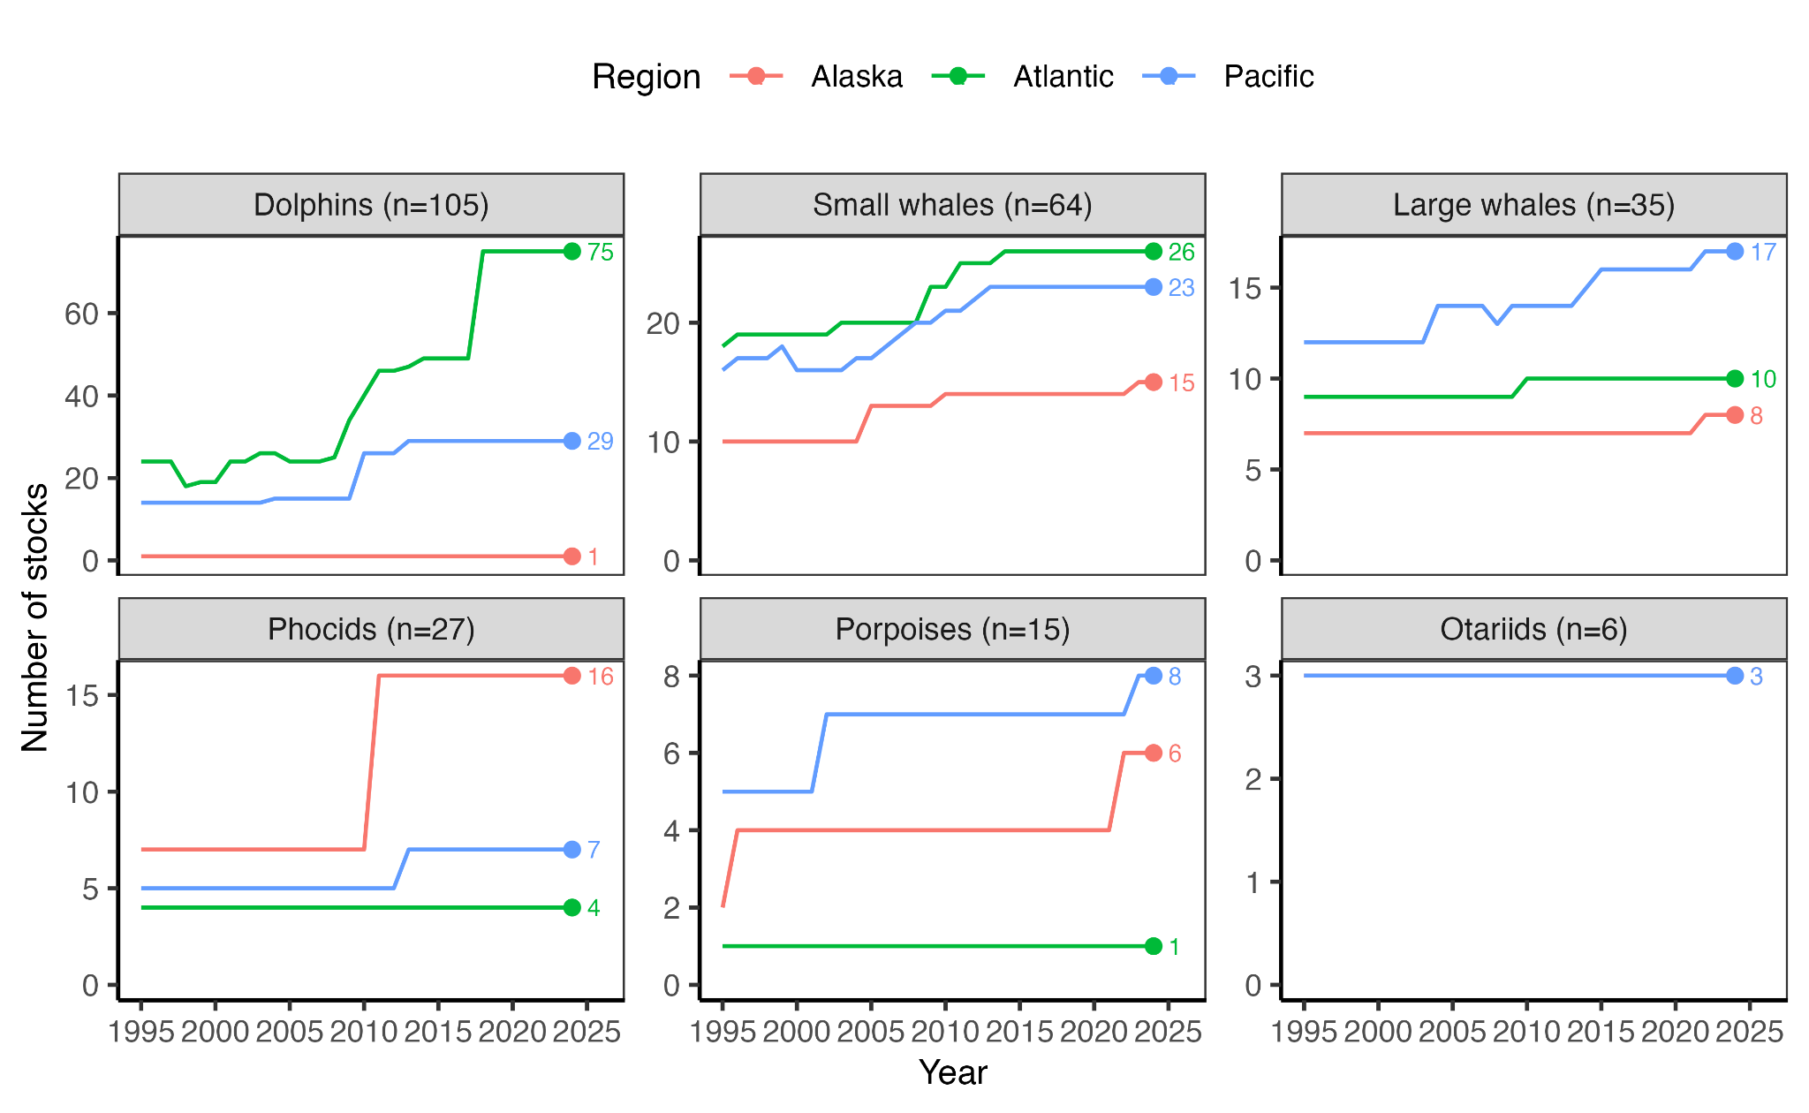
Figure 1. The number of U.S. marine mammal stocks assessed in Stock Assessment Reports (SARs) by region and taxonomic group from 1995-2024. The total number of stocks in each group in 2024 is printed in the facet label and the number of stocks in each group and region in 2024 is printed inside each plot. Short-term fluctuations in the number of Pacific whale stocks are due to three stocks that were removed from the SARs due to their rarity in U.S. waters but were later reinstated following increased occurrences (see Fig. S3).

Data to-do list
- Dip in Atlantic dolphin stocks 1998-2000 (10/11 instead of 24)
- Rise in Atlantic dolphin stocks in 2003 (26 instead of 24)

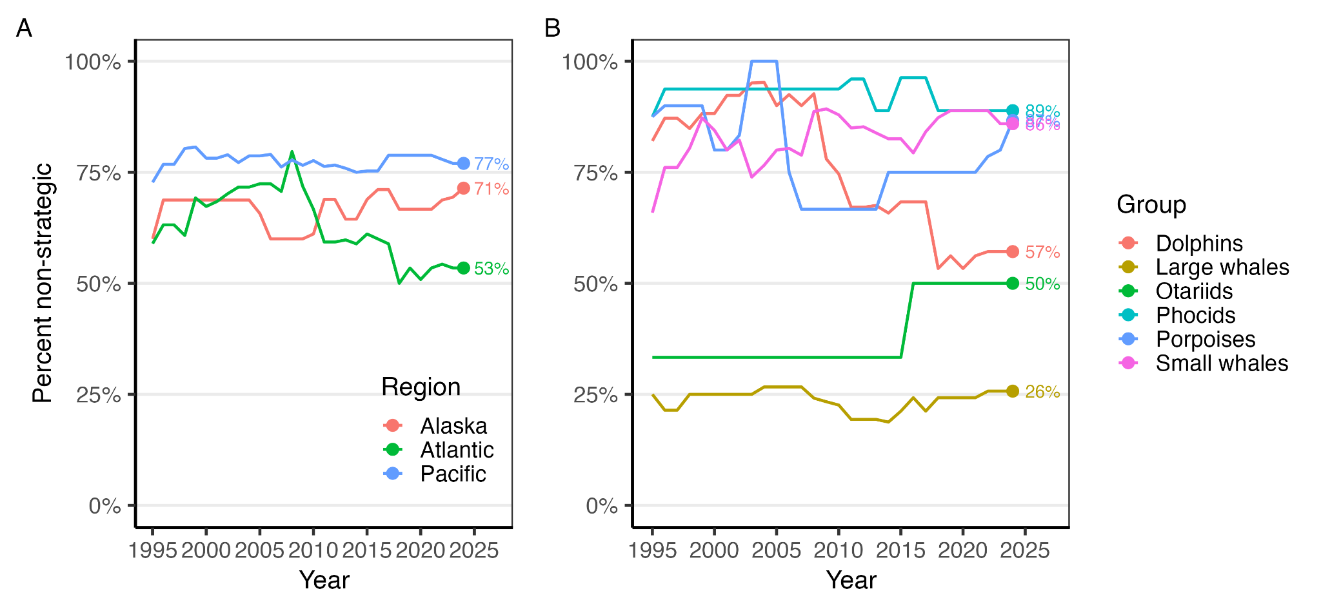Figure 2. The mortality status of U.S. marine mammal stocks from 1995-2024 by (A) region and (B) taxonomic group. Overall mortality status is represented as the percent of stocks within each category that is classified as non-strategic. Note that the number of assessed stocks has changed over time (Fig. 1).

- Align legend order with terminal year order

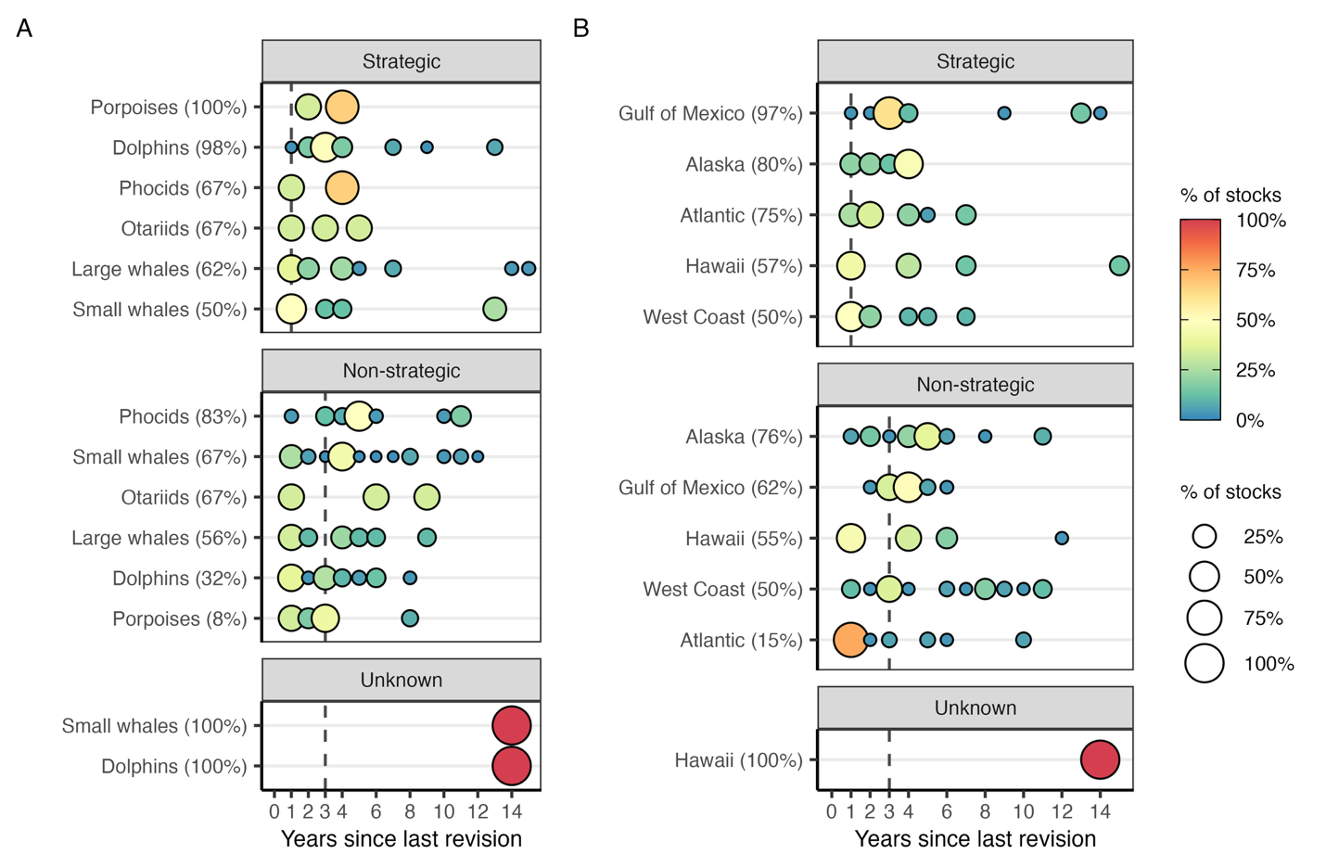Figure 3. The number of years since the last revision of the 2024 SARs by mortality status and by (A) group and (B) subregion. Points indicate the percentage of stocks within each category with a given revision interval. The MMPA requires that strategic stocks are reviewed annually and that all other stocks are reviewed every 3 years (marked by vertical lines); note, however, that they only need to be revised if new information is available. The percentage of stocks with revision intervals exceeding their status-specific requirements is provided for each category.
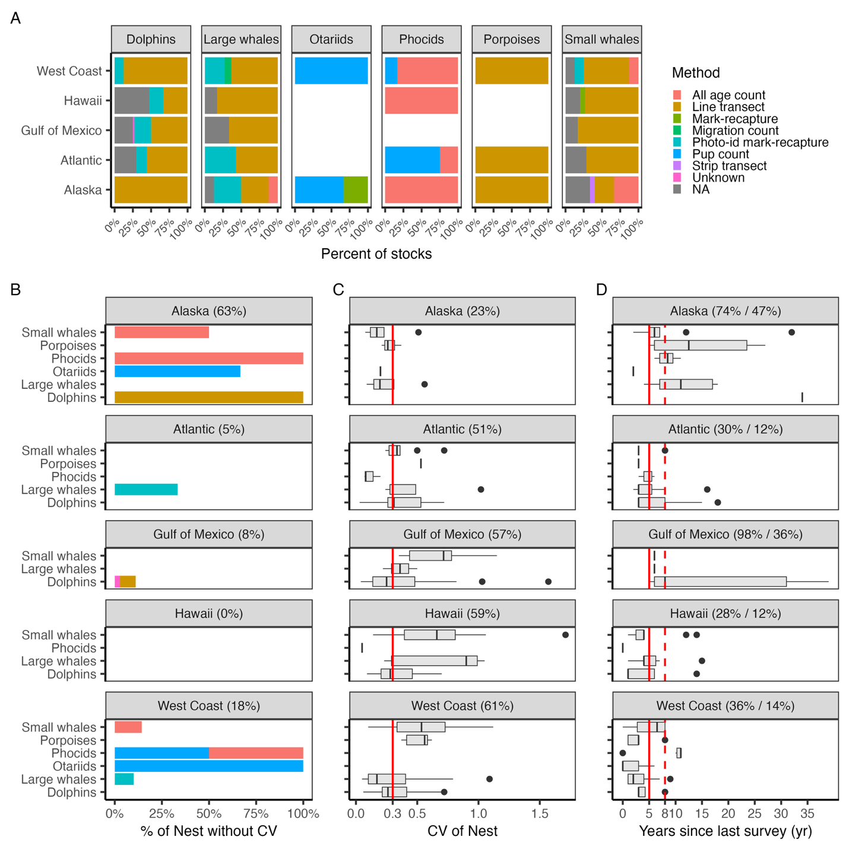Figure 4. The (A) method; (B) certainty; and (C) recency of abundance estimates in the 2024 Stock Assessment Reports by region and group. In (B), certainty is characterized by the coefficient of variation (CV) of the abundance estimate (N_{EST}). The red vertical line marks a CV of 0.3, which is NOAA’s target for scientific certainty (GAO 2008). The percent of stocks exceeding this value is printed for the whole region (in the facet) and for each group within the region (in panel). In (C), red vertical lines mark the 5- and 8-year thresholds identified as the maximum acceptable by X and Y, respectively (citations). In the boxplots, the solid line indicates the median, the box indicates the interquartile range (IQR; 25th and 75th percentiles), the whiskers indicate 1.5 times the IQR, and the points beyond the whiskers indicate outliers.
- Edit caption threshold text (plus addition of new stuff)
- Complete methods; Check for missing CVs; Add Pacific survey years
- Methods colors and ordering; work on x-axis labels
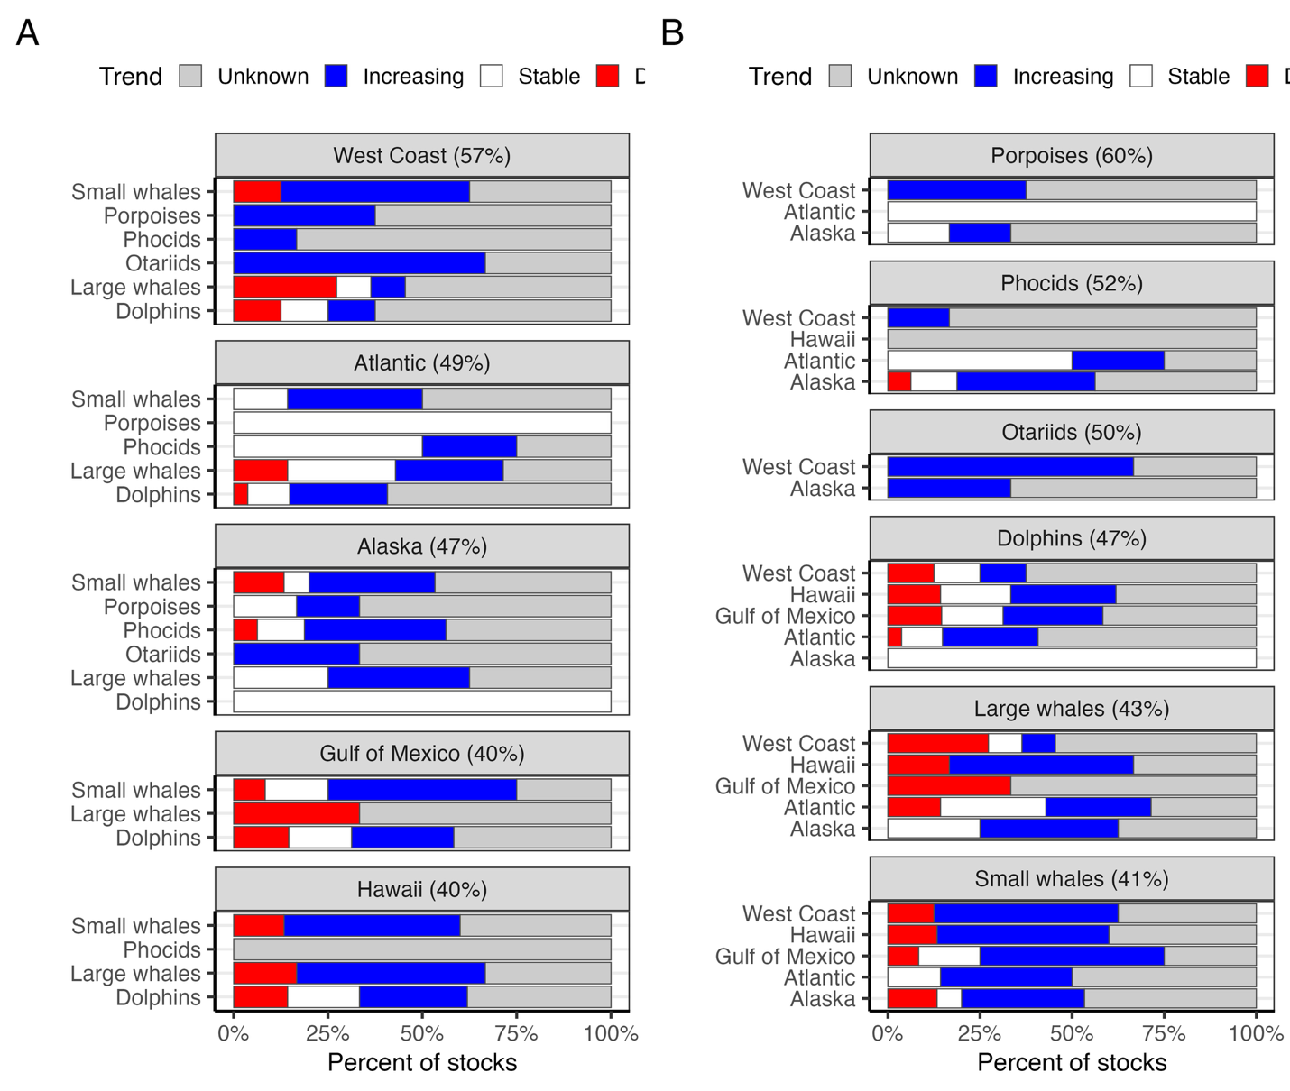Figure 5. The trend in abundance reported by the 2024 Stock Assessment Reports organized by (A) region and (B) taxonomic group. The panels display the same data but with opposite facets and y-axes to ease interpretation through two different perspectives. The percent of stocks without trend determinations within the primary group is printed in the facet label.

- Create real data
- Shrink legend/Post legend once?

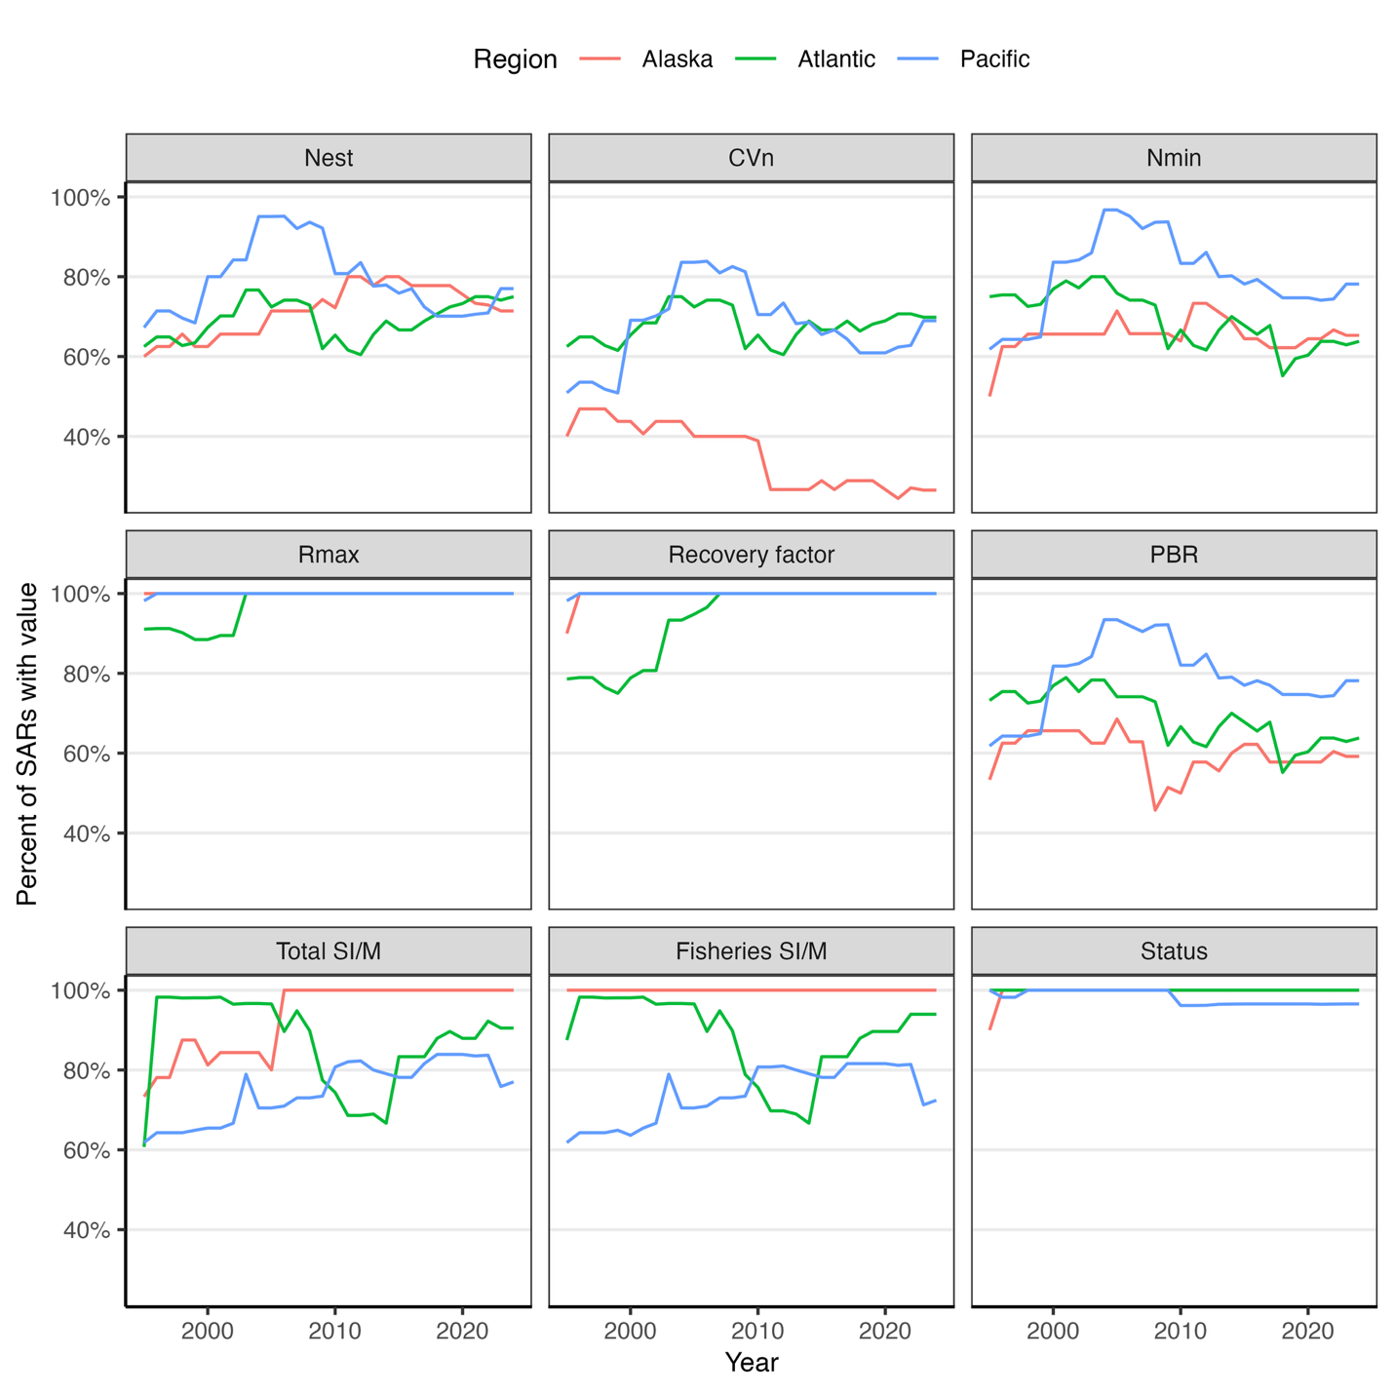Figure 6. The completeness of key management parameters across U.S. marine mammal Stock Assessment Reports from 1995-2024 by region. Note that the number of assessed stocks has changed over time (Fig. 1). Acronyms: PBR=potential biological removal; SI/M=serious injury and mortality.

- Add subscripts (ChatGPT can help)

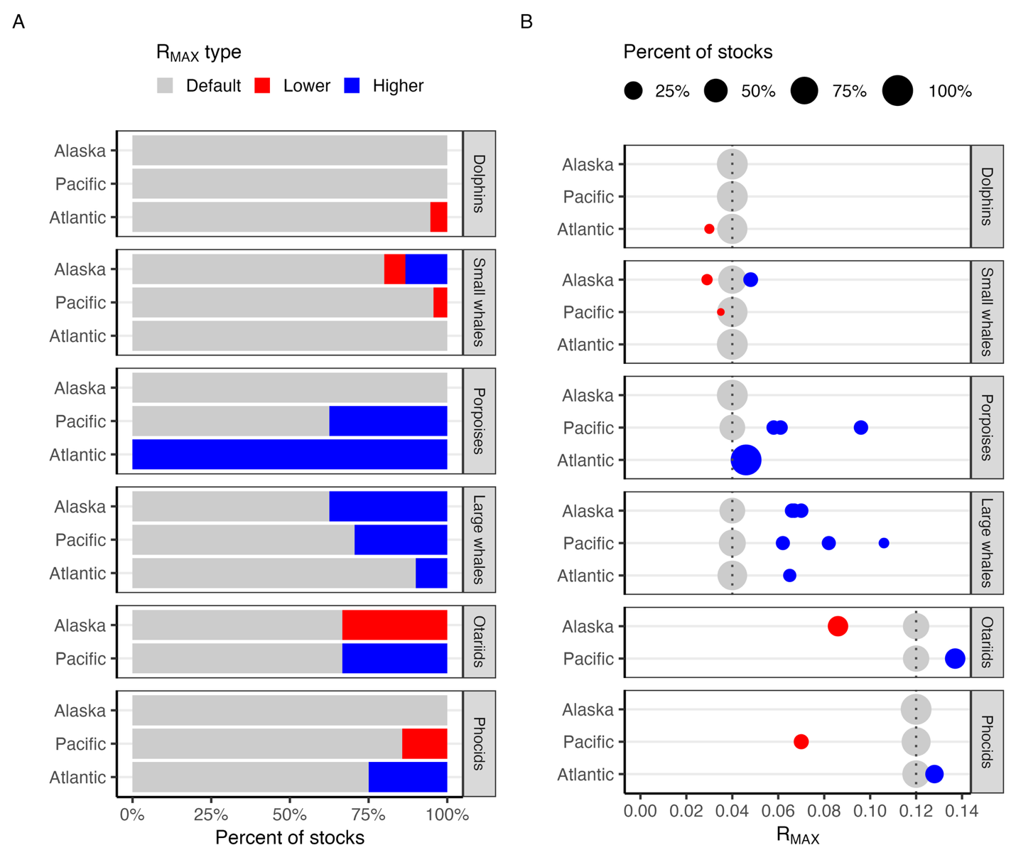
Figure 7. The (A) proportion of stocks using default R_{MAX} values and (B) the selected R_{MAX} values in the 2024 Stock Assessment Reports by region and taxonomic group. In (A), colors indicate the proportion of the stocks using the default R_{MAX} value (grey) relative to values higher (blue) or lower (red) than the default. In (B), point size represents the proportion of stocks using a given R_{MAX} value and point color indicates whether that value is the default value for that taxonomic group (grey) or a value higher (blue) or lower (red) than the default. The vertical dashed lines mark the default values for different groups (0.12 pinnipeds and sea otters, 0.04 cetaceans and manatees).

- Improve legend alignment
- Collate growth rates considered but not used in 2024 SAR (Yutian)
- Add Panel C - Difference between default and non-selected values (bias plot)
- Add panel to show change in % strategic with 25% increase-decrease in RMax
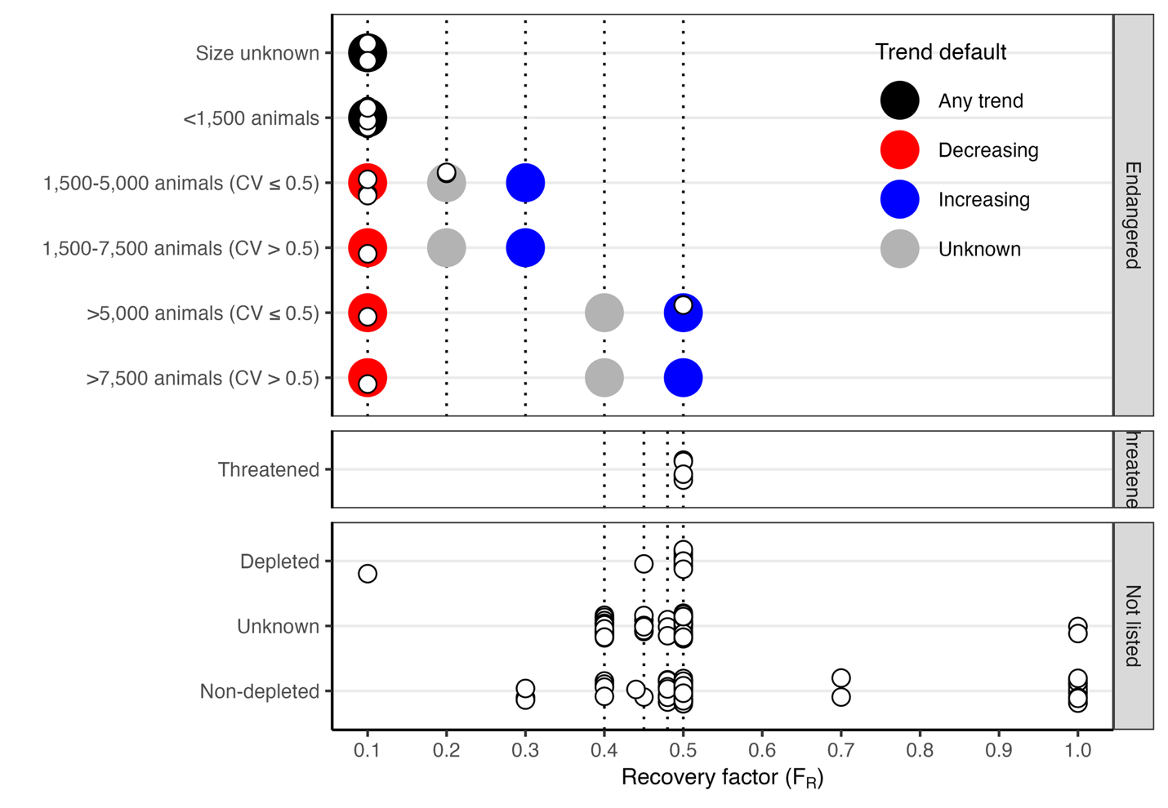 Figure 8. The recovery factors (F_{R}) used in the 2024 Stock Assessment Reports relative to official recovery factor guidelines. White points represent the F_{R} used for each stock assessment and are jittered to reduce overlap. Stocks are organized by their Endangered Species Act (ESA) status (facets) and various categories that help determine the F_{R}. The default F_{R} for Endangered species is 0.1 but can be adjusted upwards based on estimated abundance, the coefficient of variation of (CV) of estimated abundance, the trend in abundance, and the vulnerability of the stock to catastrophes (Taylor et al., 2003). The default F_{R} for Threatened or Depleted stocks and stocks with unknown status is 0.5 but can be adjusted upwards or downwards based on the CV of estimated fisheries serious injury and mortality (SI/M; downwards only) or expert consideration of other contextual factors (NMFS, 2023).

- Make white points graduated to show number of stocks instead of individual stocks?
- Color stock points by their trend
- Add fisheries SI/M CV levels, maybe?
- Note alignment/misalignment between values and guidance in caption???

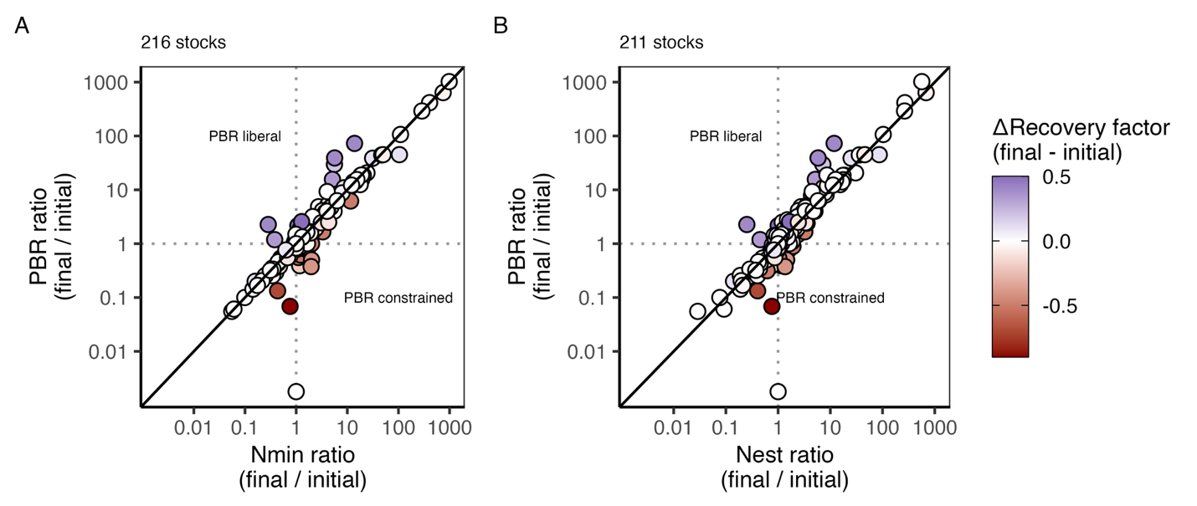Figure 9. The ratio of the potential biological removal (PBR) in the most recent year to the earliest year compared to the ratio of either the (A) minimum (N_{MIN}) or (B) best (N_{EST}) estimate of population size in the most recent year to the earliest year for all stocks managed under the Marine Mammal Protection Act (MMPA) from 1995-2024 (n=216/211; note that this includes stocks that are no longer managed under the MMPA; Figs. S1-S6). A ratio greater than 1.0 indicates growth in the value between the initial and final year while a ratio less than 1.0 indicates a reduction in the value between the initial and final year. The diagonal line marks one-to-one changes in the PBR due to changes in population size; thus, the change in the PBR for stocks falling on this is exactly proportional to the change in population size. Stocks above this line experienced changes in PBR exceeding changes in population size (i.e., PBR is liberal). Stocks below this line experienced changes in PBR less than changes in population size (i.e., PBR is constrained). The proportion of stocks that with proportional, liberal, and constrained PBR changes is printed within each plot. Point color indicates the nominal change in the recovery factor (F_{R}) between the final and initial years where reds and blues indicate reductions (increased precaution) and increases (decreased precaution) in the recovery factor, respectively. Changes in R_{MAX} can also affect this relationship (i.e., increased or decreased R_{MAX} would generate liberal or constrained PBR, respectively) but are not visualized.

- Investigate outliers (if they remain post-QA/QC)
- Subscript min and est?
- Change to “changes in PBR track, lagged, or outpaced changes in population size”
- Revisit final/initial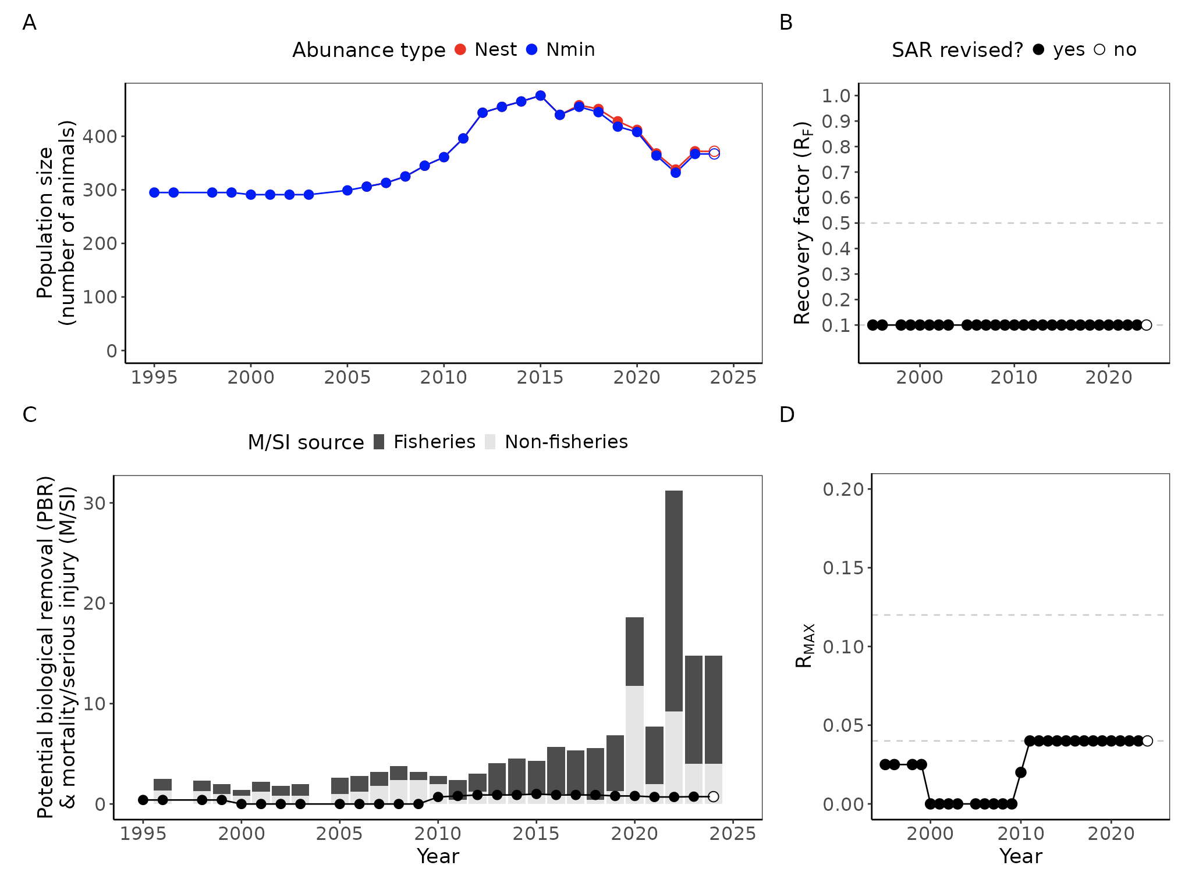Figure 10. A timeline of key management parameters for the North Atlantic right whale (Eubalaena glacialis) stock. Panel A shows trends in population size as measured by the estimated population size (N_{EST}) and the minimum population size (N_{MIN}). Panel B shows the recovery factor (F_{R}). Panel C shows the potential biological removal (PBR; points/line) relative to human-caused mortality and serious injury (M/SI; bars). Add something about strategic vs. non-strategic. Panel D shows the maximum population growth rate (R_{MAX}). Horizontal dashed lines illustrate the default values for pinnipeds and sea otters (0.12) and cetaceans and manatees (0.04). See the following interactive web explorer to visualize the management parameter timelines for any stock: https://emlab-ucsb.shinyapps.io/us_sar_data_viewer/

- Replace RF with F_{R}

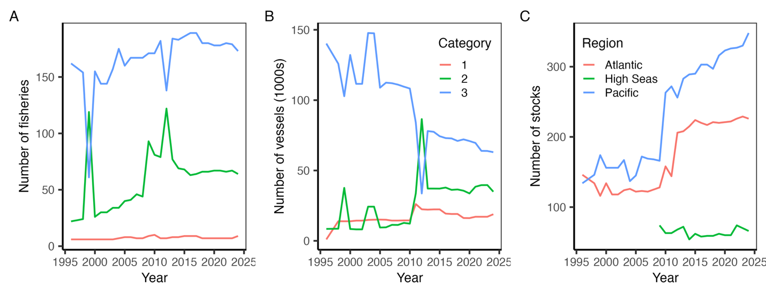Figure 11. The number of (A) fisheries listed on the List of Fisheries from 1995-2024 by category and the number of (B) vessels participating in and (C) marine mammal stocks interacting with these fisheries. Category 1, 2, and 3 fisheries result in frequent (≥50% of the potential biological removal, PBR), occasional (1-50% of the PBR), and rare (<1% of the PBR) incidental serious injury or mortality of marine mammals, respectively.

Supplemental Tables and Figures
Table S1. Structure of database documenting annual values for each stock from 1995-2024.

Attribute | Definition | Example
region | Region (Alaska, Atlantic, Pacific)
year | Year
group | Group
comm_name | Common name
species | Species
area | Area
n_est | Estimated population size (N_{EST})
n_cv | Coefficient of variation (CV) of estimated population size
n_min | Minimum population size (N_{MIN})
r_max | Maximum growth rate (R_{MAX})
rf | Recovery factor (F_{R})
pbr | Potential biological removal (PBR)
sim_total | Overall serious injury/mortality
sim_fisheries | Fisheries-related serious injury/mortality
sim_subsistence | Subsistence serious injury/mortality (AK only)
strategic_yn | Strategic or non-strategic?
revised_yn | Was the SAR revised this year?

- Add and mark 2024-only variables
Table S2. Structure of database documenting time series of survey abundance.

Attribute | Definition | Example
series_id | Time series identified
region | Region (Alaska, Atlantic, Pacific)
group | Group
comm_name | Common name
species | Species
area | Area
stock | Stock
year | Year
n_method | Method for deriving abundance estimate
n_type | Abundance type (pups, females, all, etc.)
n_est | Abundance estimate
n_est_cv | Coefficient of variation of the abundance estimate
n_est_lo | Lower confidence interval of abundance estimate
n_est_hi | Upper confidence interval of abundance estimate
reported_yn | Reported or digitized

Table S3. Structure of database documenting annual values for the List of Fisheries database.

Attribute | Definition | Example
year | Year
region | Region (Alaska, Atlantic, Pacific)
category | Category (I, II, III)
fishery_type | Fishery type (longline, gillnet, trap, etc)
fishery | Specific fishery name
nvessels | Number of vessels/people
stocks | Comma-separated list of affected species stocks

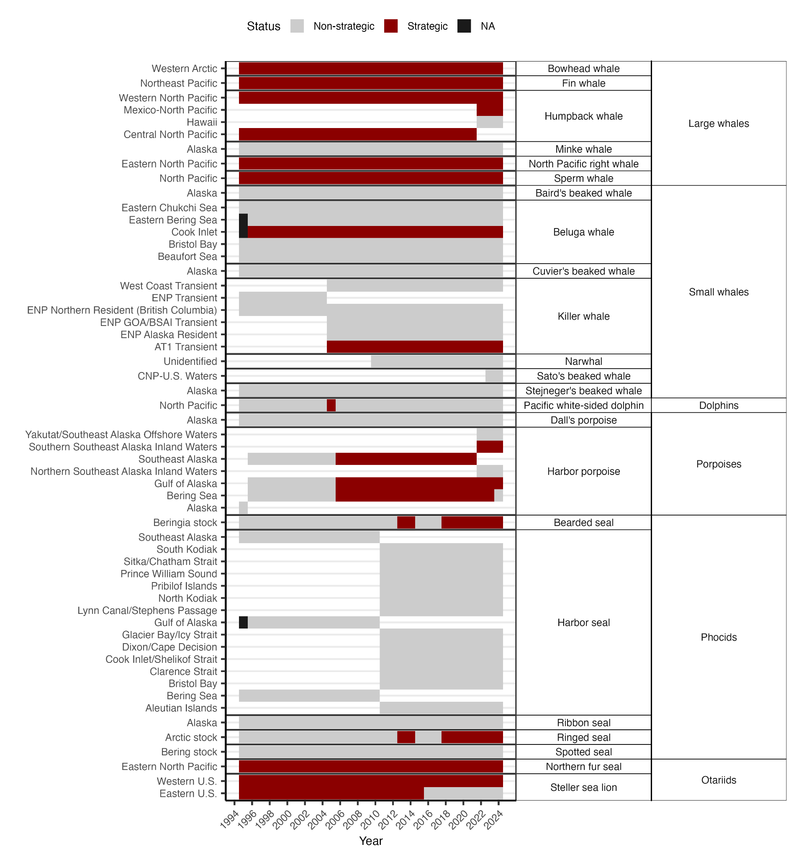Figure S1. The representation of Alaska marine mammal stocks in Stock Assessment Reports (SARs) published from 1995-2024 by taxonomic group. In many cases, a stock was split into several new stocks as stock identification tools and data improved (e.g., the Southeast Alaska harbor seal stock was split into northern inland, southern inland, offshore stocks in 2011). In several cases, a stock was added to the SARs later than 1995 (e.g., narwhal in 2010). Note that no SARs were revised for Alaska marine mammals in 1997 or 2004.

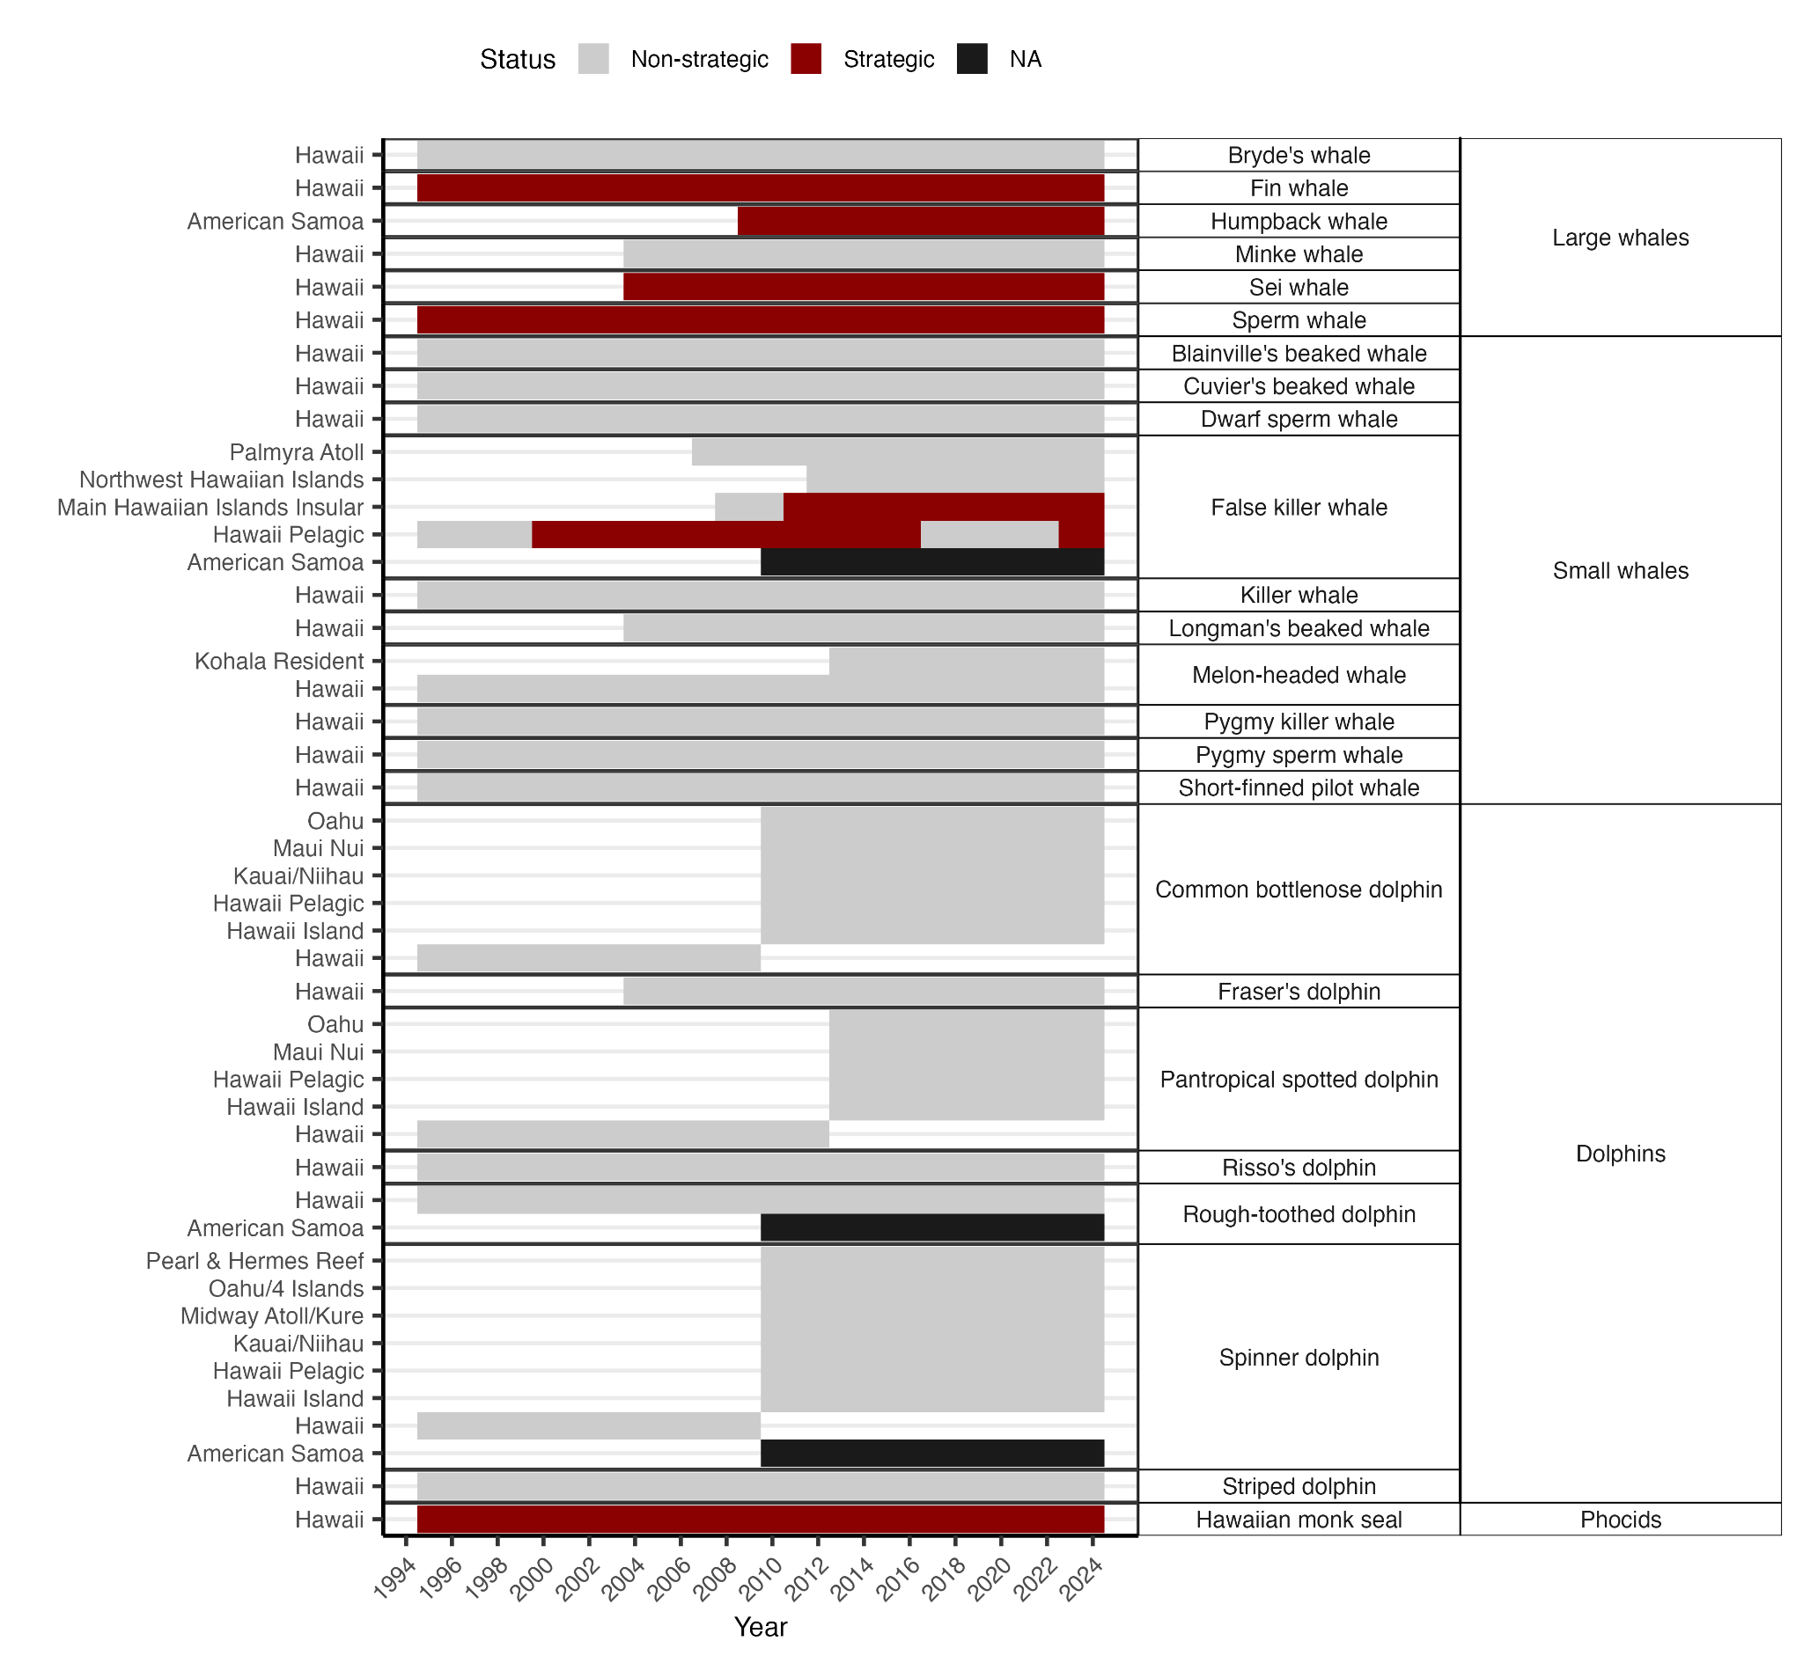Figure S2. The representation of Hawaiian and Pacific Island (Pacific region) marine mammal stocks in Stock Assessment Reports (SARs) published from 1995-2024 by taxonomic group. In many cases, a stock was split into several new stocks as stock identification tools and data improved (e.g., the Hawaii pantropical spotted dolphin stock was split into four new stocks in 2013). In several cases, a stock was added to the SARs later than 1995 (e.g., Fraser’s dolphin in 2004). Note that no SARs were revised for Hawaiian marine mammals in 1997.

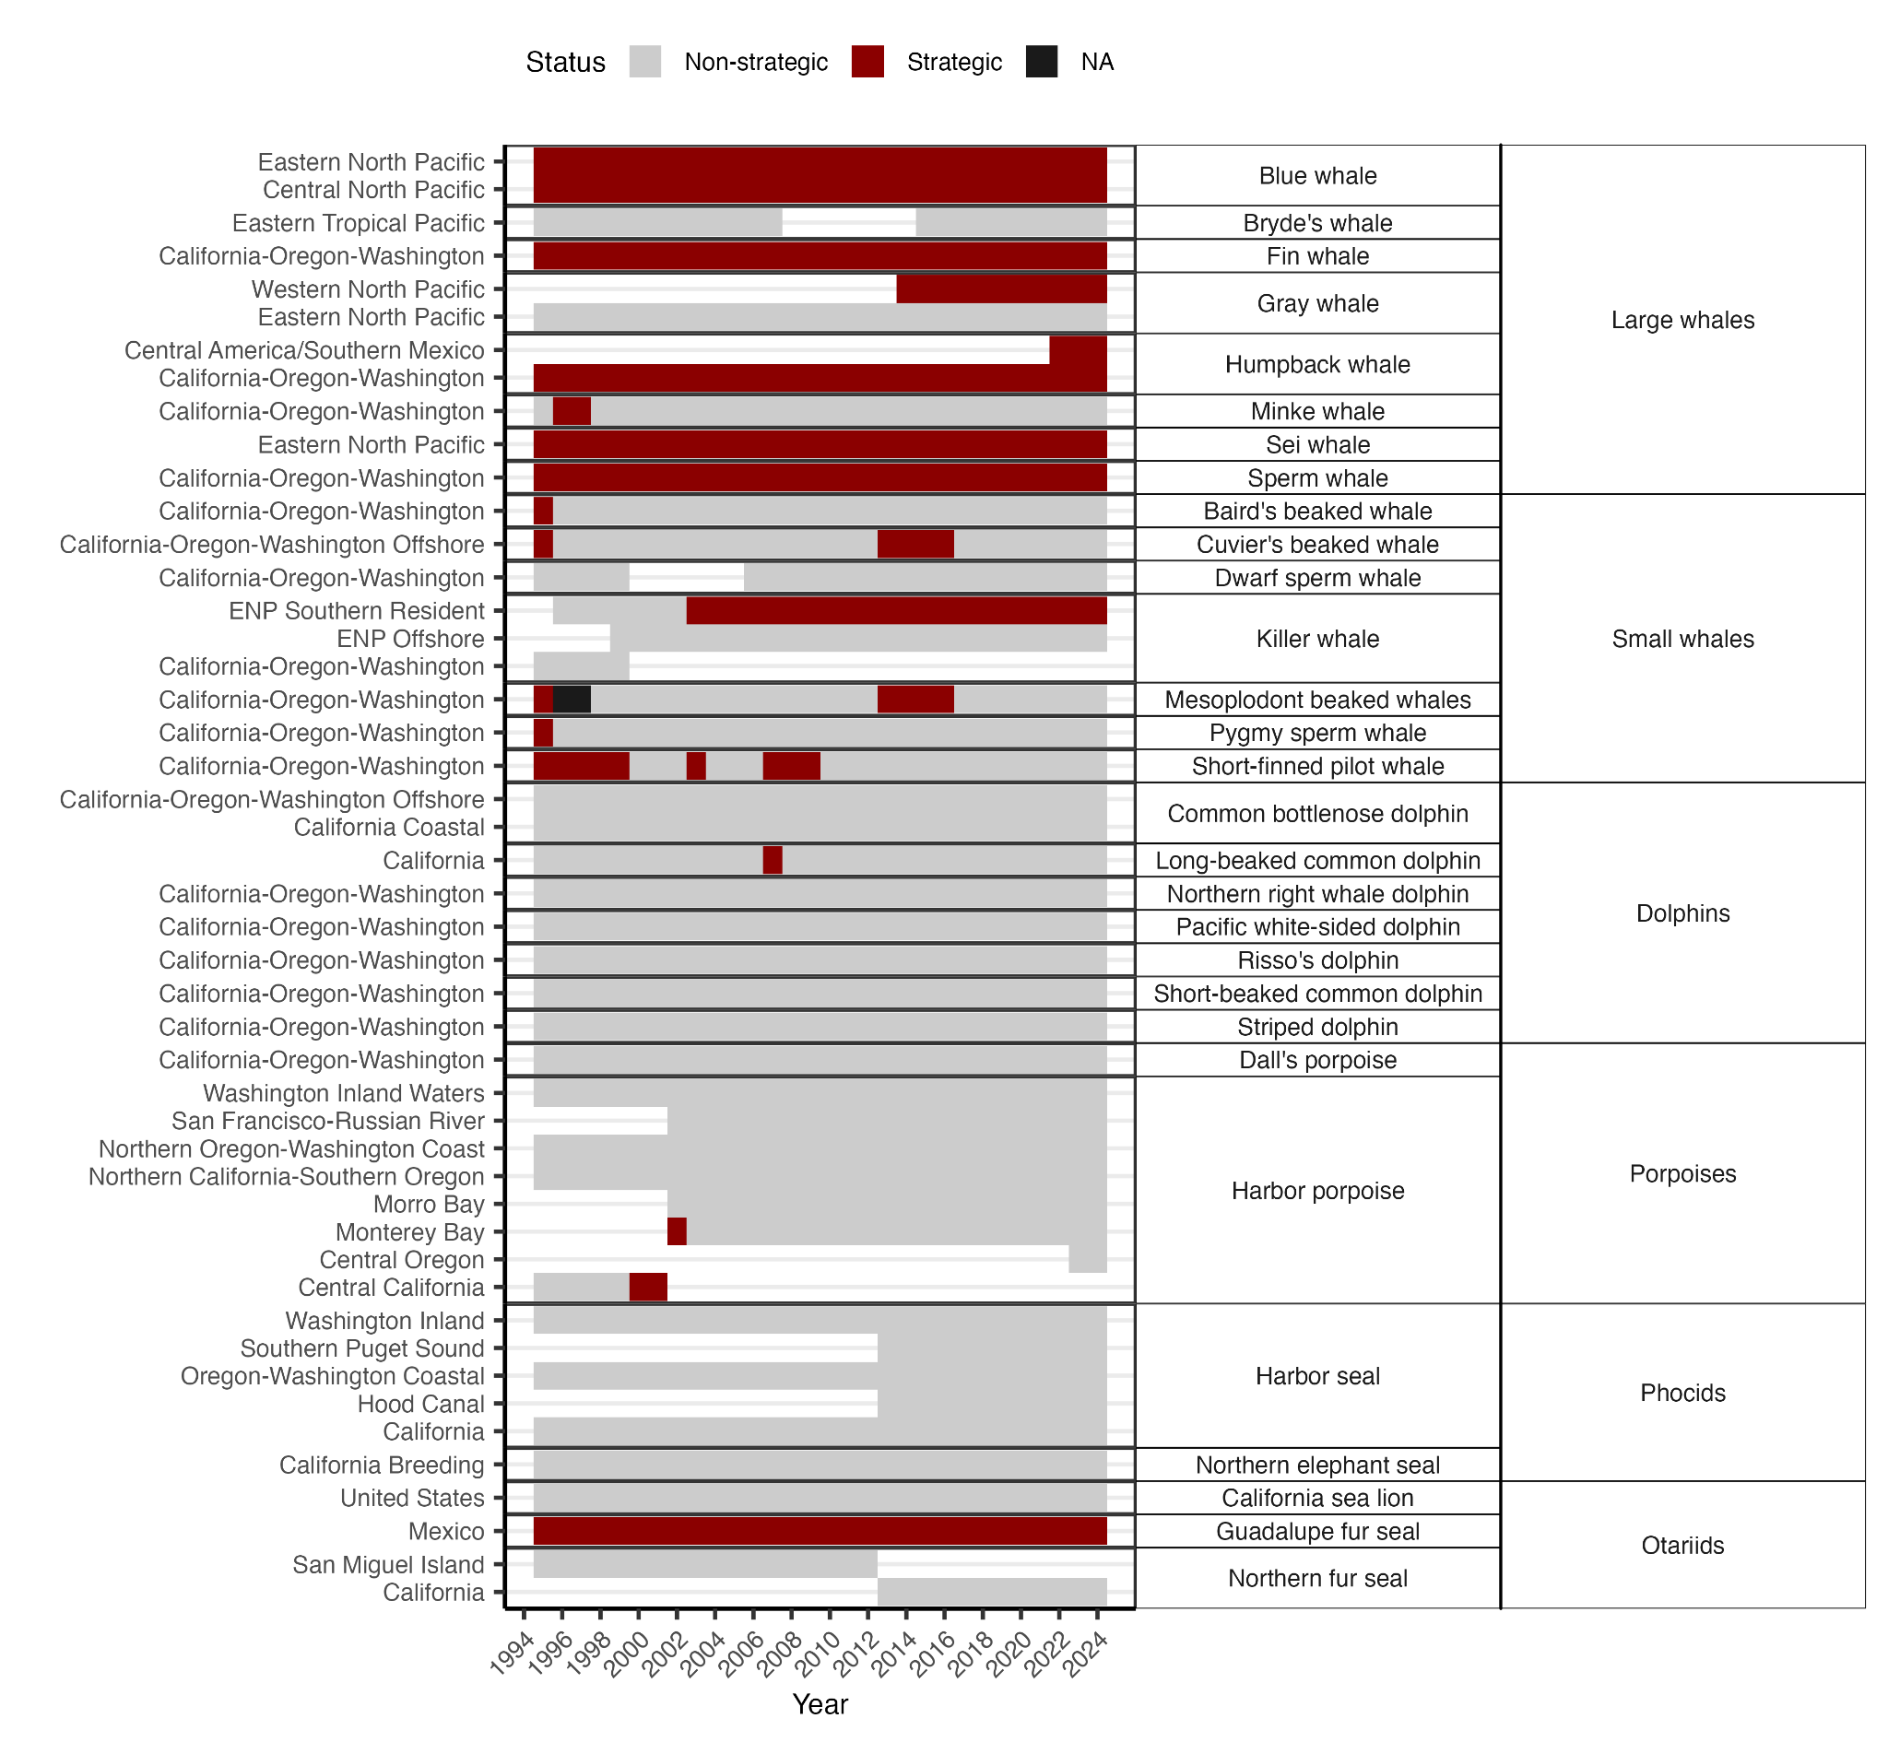Figure S3. The representation of West Coast (Pacific region) marine mammal stocks in Stock Assessment Reports (SARs) published from 1995-2024 by taxonomic group. In many cases, a stock was split into several new stocks as stock identification tools and data improved (e.g., the Central California harbor porpoise stock was split into three new stocks in 2002). In several cases, a stock was added to the SARs later than 1995 (e.g., Central Oregon harbor porpoise in 2023). In rare cases, a stock was formally removed from the SARs due to rarity in U.S. waters but brought back later following an increase in observed occurrences (e.g., CA/OR/WA dwarf sperm whale from 2000-2005, ETP Bryde’s whale from 2008-2014). A SAR for gray whale was not completed in 2004 because it was still under the jurisdiction of the Alaska Center, which did not publish SARs in 2004. Note that no SARs were revised for West Coast marine mammals in 1997.
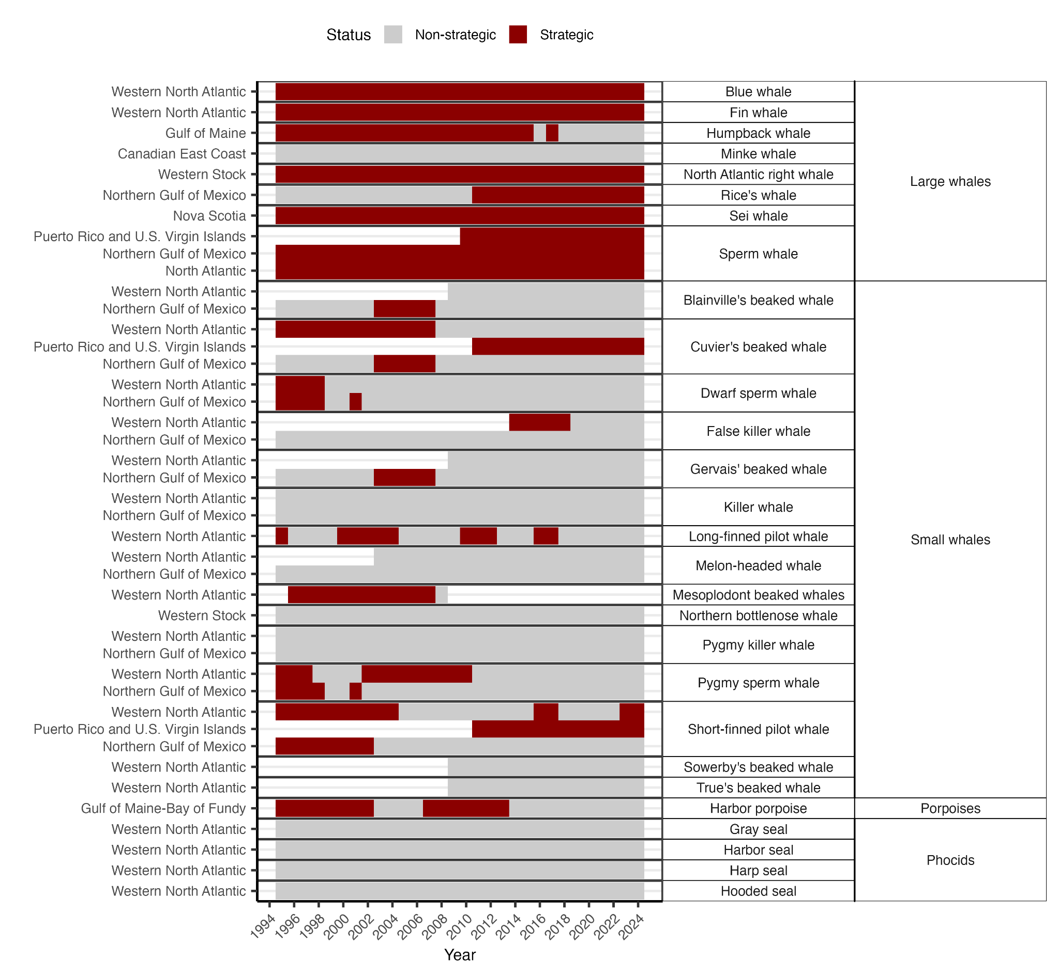Figure S4. The representation of Atlantic non-dolphin marine mammal stocks in Stock Assessment Reports (SARs) published from 1995-2024 by taxonomic group. In several cases, a stock was added to the SARs later than 1995 (e.g., XXXX in XXXX). Note that no SARs were revised for Atlantic marine mammals in 1997 or 2004. Note that Rice’s whale used to be classified as Bryde’s whale in the Atlantic.

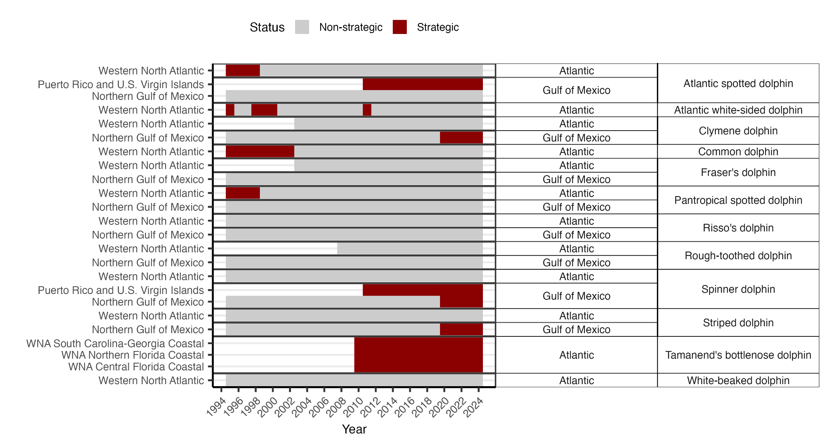Figure S5. The representation of Atlantic dolphin stocks (except common bottlenose dolphins) in Stock Assessment Reports (SARs) published from 1995-2024 by subregion (Gulf of Mexico and Atlantic). Note that no SARs were revised for Atlantic marine mammals in 1997 or 2004.

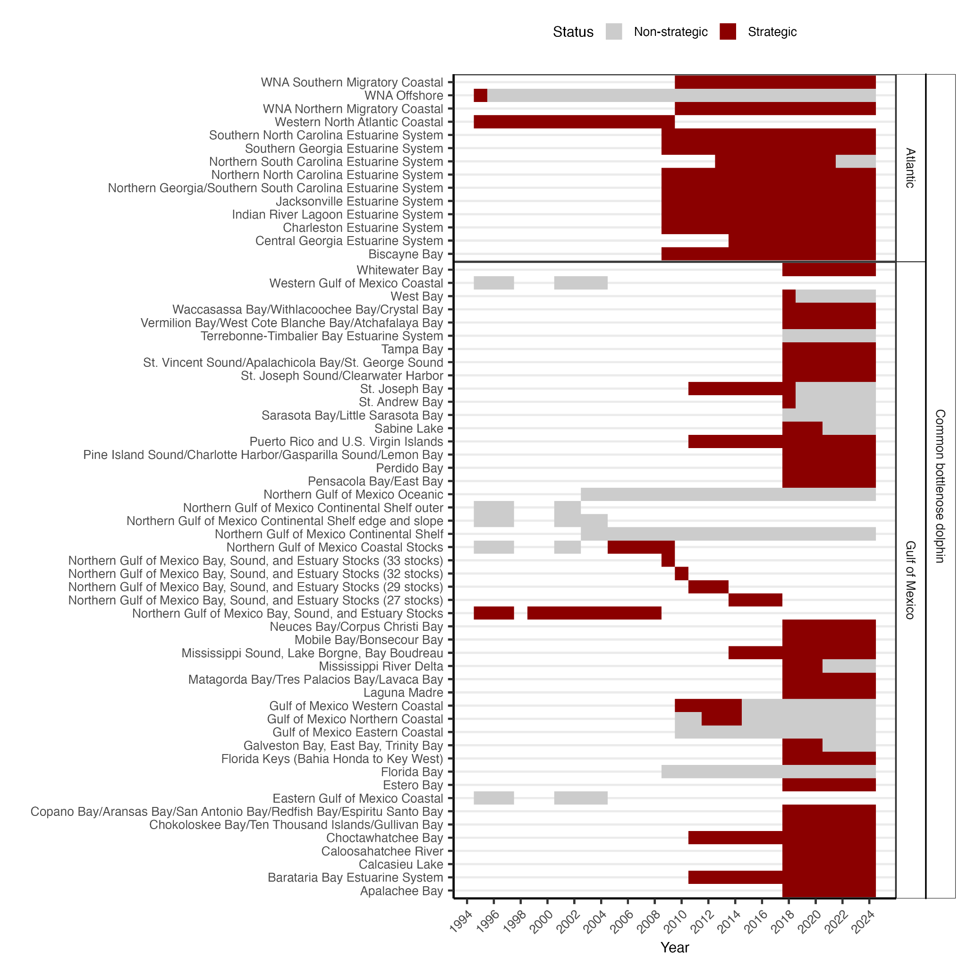Figure S6. The representation of Atlantic common bottlenose dolphin stocks in Stock Assessment Reports (SARs) published from 1995-2024 by subregion (Gulf of Mexico and Atlantic). Note that no SARs were revised for Atlantic marine mammals in 1997 or 2004.

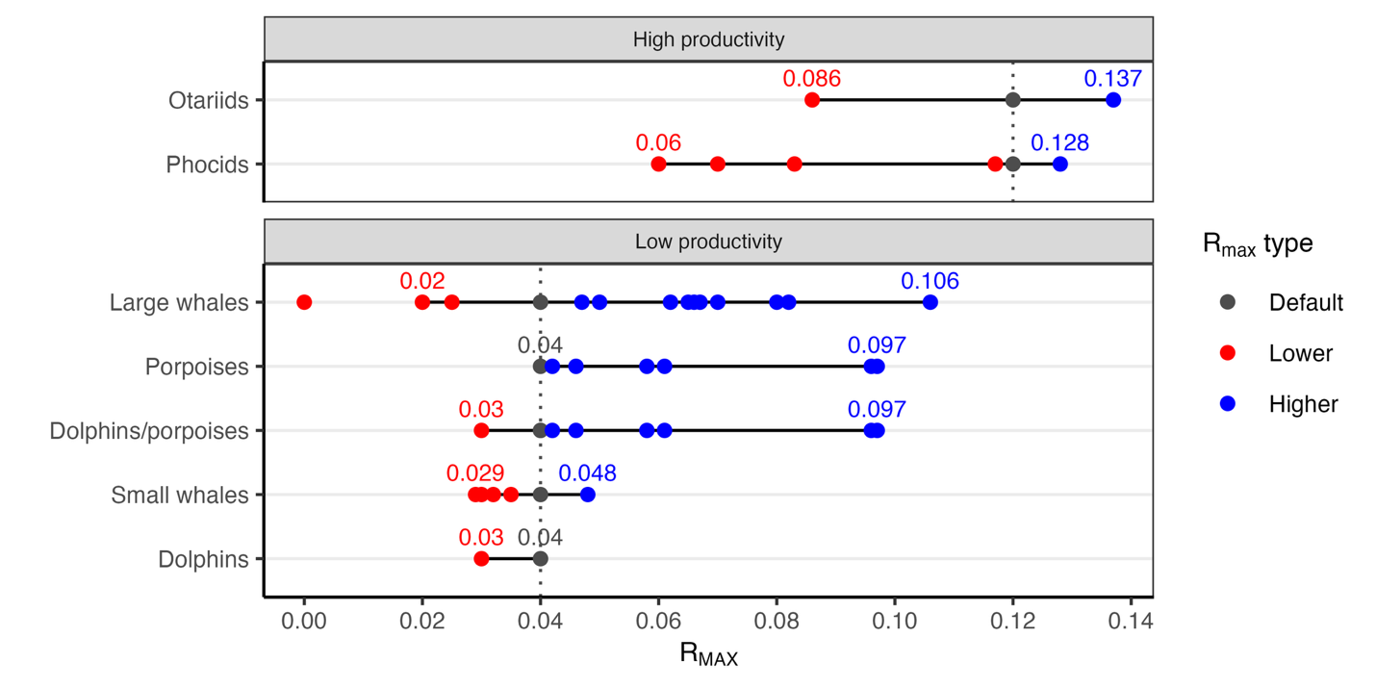
Figure S7. The unique R_{MAX} values used for stocks within each taxonomic group across from 1995-2024. The line segments delineate the range of values evaluated in the R_{MAX} sensitivity analysis and the labels indicate the limits of this range. The R_{MAX} values for dolphins and porpoises were merged because the SARs for dolphins and porpoises have never used values of R_{MAX} above or below the default, respectively. The range for large whales excludes zero, which was used as the R_{MAX} for North Atlantic right whales from 2000-2009.

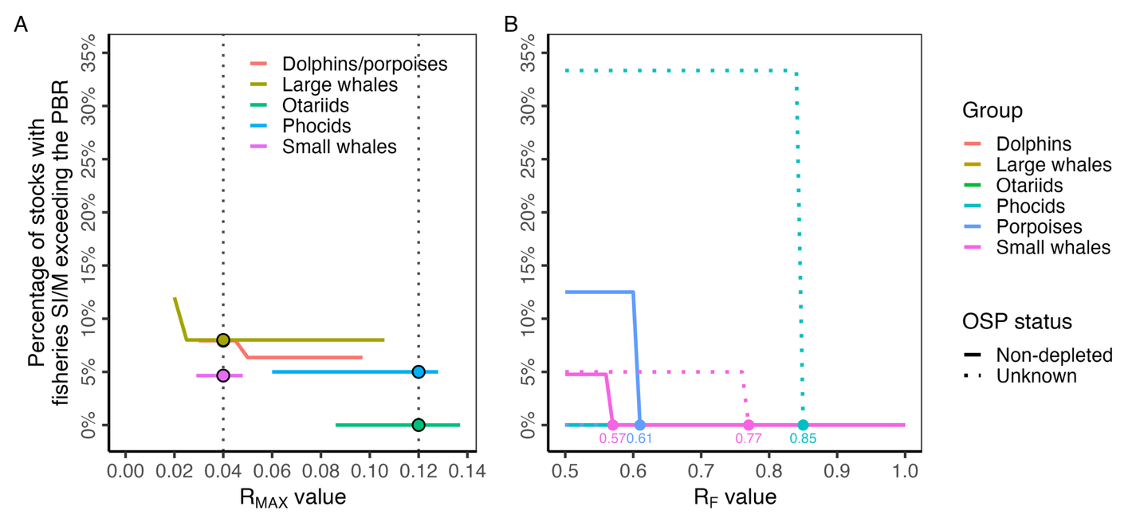

Figure S8. The sensitivity of the perceptions of the risk of fisheries to the marine mammal stocks in the 2024 SARs to changes in (A) R_{MAX} and (B) F_{R} values. In (A), lines indicate the percentage of stocks within each group with fisheries SI/M exceeding the PBR under alternative (lines) and default (points) R_{MAX} values. The vertical dashed lines mark the default values for different groups (0.12 pinnipeds and sea otters, 0.04 cetaceans and manatees). The analysis includes the XXX stocks with PBR and fisheries SI/M estimates. See Fig. S7 for the derivation of the range of R_{MAX} alternatives considered in this analysis. In (B), lines indicate the percentage of stocks within each category (group and OSP status) with fisheries SI/M exceeding the PBR under alternative (lines) F_{R} values. The points and their labels indicate the lowest F_{R} value that leads all stocks within a category to have fisheries SI/M less than the PBR; points and labels for the many categories achieving this at F_{R}=0.5 are not plotted. This analysis includes the XXX stocks of non-depleted (n=XXX) and unknown (n= XXX) abundance status with PBR and fisheries SI/M estimates.

- Fix up legends
- Make panel B points match panel A points
- Increase size on panel B labels; use adjustment
- Work in Endangered species results

